密级：机密

项目名称： | COMBO | 项目编号：
项目经理： |  | 编制：
审核： |  | 批准：

COMBO功能设计
V1.1

南京埃斯顿自动化股份有限公司

（软件技术部 V1.0 2018-06-12）

文档修订记录 Document History
序号 | 版本号 | 修订日期 | 修订概述 | 修订人 | 审批人 | 备注
1 | V1.0 | 2018.05.16 | 新建文档
2 | V1.0 | 2019.05.31 | - Add Pn parameter group names in 3.3.3,  - Add Pn addresses in 3.8.3, 3.9.3, 3.11.3, 3.12.3,  - Modify Inertia Identification Tool flow chart. | Renkai Fan
3 | V1.0 | 2019.06.05 | 1. Add Pn parameters in 3.10.3,  2. Add some information in 3.10.5 | Renkai Fan
4 | V1.0 | 2019.06.10 | 1.Add data type attribute of data monitor | Di Wu
5 | V1.0 | 2019.06.10 | Add software reset function in 3.15 | Renkai Fan
6 | V1.0 | 2019.06.11 | Change monitor data type and joint method. | Di Wu
7 | V1.0 | 2019.06.13 | Add failure information in 3.11.4. | Renkai Fan
8 | V1.0 | 2019.06.18 | 1. Modify software reset function flow chart in 3.15.4,  2. Add standard error code list of FoE in 3.13.5.  3. Add firmware naming rules in 3.13.5. | Renkai Fan
9 | V1.1 | 2020.01.02 | 1. Add JOG and PJOG function | Renkai Fan
目 录
1 目的 - 1 -
2 范围 - 1 -
3 详细功能描述 - 1 -
3.1 伺服信息显示 Servo Information Display - 1 -
3.1.1 功能描述 function description - 1 -
3.1.2 期望目标 function definition details - 1 -
3.1.3 详细通讯对象 communication objects details - 1 -
3.1.4 通讯流程图 communication flow chart - 1 -
3.1.5 相关算法 algorithm - 2 -
3.1.6 关键技术点及风险点 key technologies and risks - 2 -
3.2 参数编辑功能 Parameter Edit - 2 -
3.2.1 功能描述function description - 2 -
3.2.2 期望目标function details definition - 2 -
3.2.3 详细通讯对象 communication objects details - 2 -
3.2.4 通讯流程图 communication flow chart - 2 -
3.2.5 相关算法 algorithm - 2 -
3.2.6 关键技术点及风险点 key technologies and risks - 3 -
3.3 伺服状态监控 Servo Status Monitor - 3 -
3.3.1 功能描述function description - 3 -
3.3.2 期望目标function details definition - 3 -
3.3.3 详细通讯对象 communication objects details - 3 -
3.3.4 通讯流程图 communication flow chart - 3 -
3.3.5 相关算法 algorithm - 3 -
3.3.6 关键技术点及风险点 key technologies and risks - 3 -
3.4 数据监控/IO监控 Data / IO Monitor - 4 -
3.4.1 功能描述function description - 4 -
3.4.2 期望目标function details definition - 4 -
3.4.3 详细通讯对象 communication objects details - 4 -
3.4.4 通讯流程图 communication flow chart - 4 -
3.4.5 相关算法 algorithm - 4 -
3.4.6 关键技术点及风险点 key technologies and risks - 4 -
3.5 报警显示功能 Alarm Display - 4 -
3.5.1 功能描述function description - 4 -
3.5.2 期望目标function details definition - 5 -
3.5.3 详细通讯对象 communication objects details - 5 -
3.5.4 通讯流程图 communication flow chart - 5 -
3.5.5 相关算法 algorithm - 5 -
3.5.6 关键技术点及风险点 key technologies and risks - 5 -
3.6 ABS encoder操作ABS Encoder Operation - 5 -
3.6.1 功能描述function description - 5 -
3.6.2 期望目标function details definition - 5 -
3.6.3 详细通讯对象 communication objects details - 5 -
3.6.4 通讯流程图 communication flow chart - 6 -
3.6.5 相关算法 algorithm - 6 -
3.6.6 关键技术点及风险点 key technologies and risks - 6 -
3.7 Tuning免调整 - 6 -
3.7.1 功能描述function description - 6 -
3.7.2 期望目标function details definition - 6 -
3.7.3 详细通讯对象 communication objects details - 6 -
3.7.4 通讯流程图 communication flow chart - 6 -
3.7.5 相关算法 algorithm - 7 -
3.7.6 关键技术点及风险点 key technologies and risks - 7 -
3.8 Tuning在线参数调整-自动调整 - 7 -
3.8.1 功能描述function description - 7 -
3.8.2 期望目标function details definition - 7 -
3.8.3 详细通讯对象 communication objects details - 7 -
3.8.4 通讯流程图 communication flow chart - 7 -
3.8.5 相关算法 algorithm - 7 -
3.8.6 关键技术点及风险点 key technologies and risks - 7 -
3.9 Tuning在线参数调整-手动调整 - 8 -
3.9.1 功能描述function description - 8 -
3.9.2 期望目标function details definition - 8 -
3.9.3 详细通讯对象 communication objects details - 8 -
3.9.4 通讯流程图 communication flow chart - 8 -
3.9.5 相关算法 algorithm - 8 -
3.9.6 关键技术点及风险点 key technologies and risks - 8 -
3.10 Tuning离线参数调整-自动调整 - 8 -
3.10.1 功能描述function description - 8 -
3.10.2 期望目标function details definition - 9 -
3.10.3 详细通讯对象 communication objects details - 9 -
3.10.4 通讯流程图 communication flow chart - 9 -
3.10.5 相关算法 algorithm - 9 -
3.10.6 关键技术点及风险点 key technologies and risks - 9 -
3.11 负载惯量检测 - 9 -
3.11.1 功能描述function description - 9 -
3.11.2 期望目标function details definition - 10 -
3.11.3 详细通讯对象 communication objects details - 11 -
3.11.4 通讯流程图 communication flow chart - 11 -
3.11.5 相关算法 algorithm - 13 -
3.11.6 关键技术点及风险点 key technologies and risks - 13 -
3.12 在线升级 - 13 -
3.12.1 功能描述function description - 13 -
3.12.2 期望目标function details definition - 13 -
3.12.3 详细通讯对象 communication objects details - 13 -
3.12.4 通讯流程图 communication flow chart - 13 -
3.12.5 相关算法 algorithm - 13 -
3.12.6 关键技术点及风险点 key technologies and risks - 14 -
3.13 Scope功能？？ - 14 -
3.13.1 功能描述function description - 14 -
3.13.2 期望目标function details definition - 14 -
3.13.3 详细通讯对象 communication objects details - 14 -
3.13.4 通讯流程图 communication flow chart - 14 -
3.13.5 相关算法 algorithm - 14 -
3.13.6 关键技术点及风险点 key technologies and risks - 14 -
4 供参考的ESView描述 - 15 -
4.1 Trace功能块 - 15 -
4.1.1 功能描述 - 15 -
4.1.2 期望目标 - 15 -
4.1.3 详细通讯地址 - 15 -
4.1.4 通讯流程图 - 16 -
4.1.5 相关算法 - 16 -
4.1.6 关键技术点及风险点 - 16 -
4.2 负载惯量检测 - 16 -
4.2.1 功能描述 - 16 -
4.2.2 期望目标 - 17 -
4.2.3 详细通讯地址 - 18 -
4.2.4 通讯流程图 - 19 -
4.2.5 相关算法 - 20 -
4.2.6 关键技术点及风险点 - 20 -
4.3 摩擦补偿 - 20 -
4.3.1 功能描述 - 20 -
4.3.2 期望目标 - 20 -
4.3.3 详细通讯地址 - 23 -
4.3.4 通讯流程图 - 23 -
4.3.5 相关算法 - 24 -
4.3.6 关键技术点及风险点 - 25 -
4.4 离线参数整定-自动 - 25 -
4.4.1 功能描述 - 25 -
4.4.2 期望目标 - 26 -
4.4.3 详细通讯地址 - 30 -
4.4.4 通讯流程图 - 32 -
4.4.5 相关算法 - 33 -
4.4.6 关键技术点及风险点 - 33 -
4.5 免调整 - 33 -
4.5.1 功能描述 - 33 -
4.5.2 期望目标 - 33 -
4.5.3 详细通讯地址 - 35 -
4.5.4 通讯流程图 - 35 -
4.5.5 相关算法 - 36 -
4.5.6 关键技术点及风险点 - 36 -
4.6 单参数调谐Mode1 - 36 -
4.6.1 功能描述 - 36 -
4.6.2 期望目标 - 36 -
4.6.3 详细通讯地址 - 37 -
4.6.4 通讯流程图 - 38 -
4.6.5 相关算法 - 39 -
4.6.6 关键技术点及风险点 - 39 -
4.7 单参数调谐Mode2 - 39 -
4.7.1 功能描述 - 39 -
4.7.2 期望目标 - 39 -
4.7.3 详细通讯地址 - 40 -
4.7.4 通讯流程图 - 41 -
4.7.5 相关算法 - 42 -
4.7.6 关键技术点及风险点 - 42 -
4.8 手动调谐Mode1 - 42 -
4.8.1 功能描述 - 42 -
4.8.2 期望目标 - 42 -
4.8.3 详细通讯地址 - 47 -
4.8.4 通讯流程图 - 48 -
4.8.5 相关算法 - 49 -
4.8.6 关键技术点及风险点 - 49 -
4.9 手动调谐Mode2 - 49 -
4.9.1 功能描述 - 49 -
4.9.2 该功能可用于一些负载惯量比固定的场合。期望目标 - 49 -
4.9.3 详细通讯地址 - 53 -
4.9.4 通讯流程图 - 54 -
4.9.5 相关算法 - 54 -
4.9.6 关键技术点及风险点 - 54 -
4.10 程序位置JOG - 55 -
4.10.1 功能描述 - 55 -
4.10.2 期望目标 - 55 -
4.10.3 详细通讯地址 - 56 -
4.10.4 通讯流程图 - 57 -
4.10.5 相关算法 - 59 -
4.10.6 关键技术点及风险点 - 59 -
4.11 电机动力线接线离线诊断功能块 - 59 -
4.11.1 功能描述 - 59 -
4.11.2 期望目标 - 59 -
4.11.3 详细通讯地址 - 59 -
4.11.4 通讯流程图 - 60 -
4.11.5 相关算法 - 60 -
4.11.6 关键技术点及风险点 - 60 -
4.12 Esview电机参数导入/读取功能 - 60 -
4.12.1 功能描述 - 60 -
4.12.2 期望目标 - 61 -
4.12.3 详细通讯地址 - 61 -
4.12.4 通讯流程图 - 62 -
4.12.5 相关算法 - 62 -
4.12.6 关键技术点及风险点 - 62 -
4.13 配置EtherCAT回零方式 - 62 -
4.13.1 功能描述 - 62 -
4.13.2 期望目标 - 62 -
4.13.3 详细通讯地址 - 63 -
4.13.4 通讯流程图 - 66 -
4.13.5 相关算法 - 66 -
4.13.6 关键技术点及风险点 - 66 -
4.14 编码器设定以及读取（第二编码器设定） - 66 -
4.14.1 功能描述 - 66 -
4.14.2 期望目标 - 67 -
4.14.3 详细通讯地址 - 67 -
4.14.4 通讯流程图 - 69 -
4.14.5 相关算法 - 69 -
4.14.6 关键技术点及风险点 - 69 -
4.15 参数表设计 - 69 -
4.15.1 功能描述 - 69 -
4.15.2 期望目标 - 69 -
4.15.3 详细通讯地址 - 70 -
4.15.4 通讯流程图 - 70 -
4.15.5 相关算法 - 70 -
4.15.6 关键技术点及风险点 - 70 -
4.16 示波器参数规格设计 - 70 -
4.16.1 功能描述 - 70 -
4.16.2 期望目标 - 70 -
4.16.3 详细通讯地址 - 70 -
4.16.4 通讯流程图 - 72 -
4.16.5 相关算法 - 72 -
4.16.6 关键技术点及风险点 - 72 -

目的
编写此文档的目的是规范伺服功能描述，重点描述上下位机通信时关心的数据和内容。方便软件设计团队和伺服设计团队进行技术层面交流。方便系统工程师把控项目中技术难点和风险点。

范围
此文档适配COMBO驱动器功能。

详细功能描述

高级用户权限 Advanced user rights

功能描述 function description
获取高级用户权限功能。用户获取高级用户权限后，能够操作更多的功能，读写更多的参数，监控或显示更多的数据或信息。
The advanced users are allowed to operate more funcitons,read and write more parameters,display or monitor more information or data.

期望目标 function definition details

详细通讯对象 communication objects details
Name | Index | Sub-index | Access | Value
用户密码  Advance password | 0x2004 | 1 | RW | 2008

通讯流程图 communication flow chart
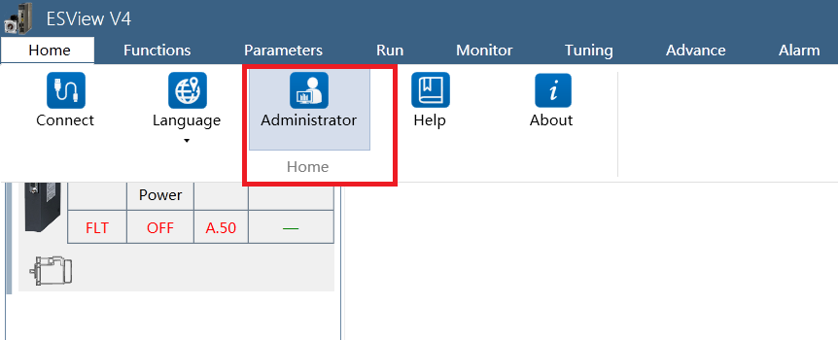
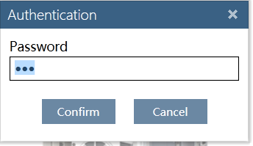

When users insert the wrong password and Click “Confirm”, window as followings will be pop up.
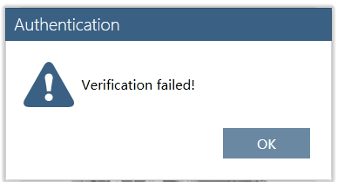
If the password is right , window will be
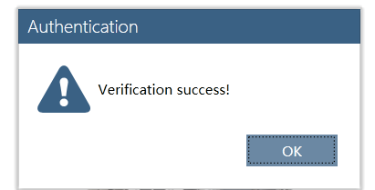
At the same time, MPV4 will write the correct password to the corresponding index. Servo driver will change the authority to high level.

Tips:
- The right password user inserted is different from the password that Motion Perfect sends to servo.
Like in Esview, user input"estun2018" into the Esview password box, then Esview send 2008(Uint16 type，not string) to servo. So 2008 is different from "estun2018".
- It is not necessary for Motion Perfect to know whether the servo driver is in advanced status or not.

相关算法 algorithm

关键技术点及风险点 key technologies and risks
All the indexes in this chapter can be read after the communication is connected. Which information will be displayed is determined by MPV4.

伺服信息显示 Servo Information Display

功能描述 function description
显示伺服系统信息。
Display of servo system information.

期望目标 function definition details

详细通讯对象 communication objects details

Name | Index | Sub-index | Access | Value
驱动器型号  Drive model | 0x2003 | 01h~14h | RO | drive-type string(ASCII), every 8bit means one character, such as 0x3231 means string “21”
DSP版本  DSP firmware version | 0x2005 | 1 | RO | Return version data, such as 0x1018 means version is V101.8
FPGA版本  FPGA firmware version | 0x2006 | 1 | RO | Return version data, such as 0x1018 means version is V101.8
BOOT版本（需要高级权限显示）  Boot firmware version (Only be displayed with high authority) | 0x2007 | 1 | RO | Return version data, such as 0x1001 means version is V100.1.
电机参数表版本（需要高级权限显示）  Motor parameters table version (Only be displayed with high authority). | 0x2008 | 1 | RO | Return version data, such as 0x1001 means version is V100.1.
电机型号  Motor model | 0x3000 | 1 | RO | Motor-type string(ASCII), every 8bit means one character, such as 0x3231 means string “21”

通讯流程图 communication flow chart

相关算法 algorithm

关键技术点及风险点 key technologies and risks
All the indexes in this chapter can be read after the communication is connected. Which information will be displayed is determined by MPV4.

参数编辑功能 Parameter Edit

功能描述function description
MPV4 allows users to edit,download,upload servo parameters. Additionally,users can recover all the allowable parameters to the default values.MPV4 provided two levels of authority.The users of low authority are not allowed to see some manufacture private parameters.Relatively,the users of high authority are allowed to see and edit all theparameters.Thehigh authority can be obtained by insert the right password.

期望目标function details definition

详细通讯对象 communication objects details
Name | Index | Sub-index | Access | Value
参数编辑功能  Parameters edit function | 3100-313F |  | RW
恢复出厂值  Recover to default values | 3110 |  | RW | Recover all the displayed parameters to default values
Pn参数  Pn-Parameters | 3164-3653 |  | RW
功能开关PN0（8）  Pn0-group:Function Switch | 3164-316B |  | RW
增益参数PN1（92）  Pn1-group:Gain | 31C8-3223 |  | RW
位置环相关参数PN2（15）  Pn2-group: Position Loop | 322C-323A |  | RW
速度环相关参数PN3（33）  Pn3-group: Speed Loop | 3290-32B0 |  | RW
转矩环相关参数PN4（9）  Pn4-group: Torque Loop | 32F4-32FC |  | RW
IO相关参数PN5（52）  Pn5-group: IO | 3358-338B |  | RW
总线通讯相关参数PN6（0）  Pn6-group: Reserved | 33BC- |  | RW
总线通讯相关参数PN7（27）  Pn7-group: Bus Communication | 3420-343A |  | RW
高级参数PN8（96）  Pn8-group:Advanced Parameters | 3484-34E3 |  | RW
测试参数PN9（66）  Pn9-group: Test Parameters | 34E8-3529 |  | RW
Reserved | 3654-367F |  | RW

Tips:
Several parameters may be reserved among every parameter group. Accurate parameter OD index may be according to servo driver parameter table excel.

通讯流程图 communication flow chart
- Recover to default values

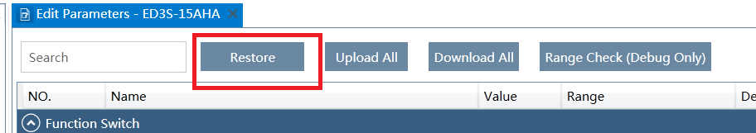

Users press button “Restore” and then tips window was pop up window1.

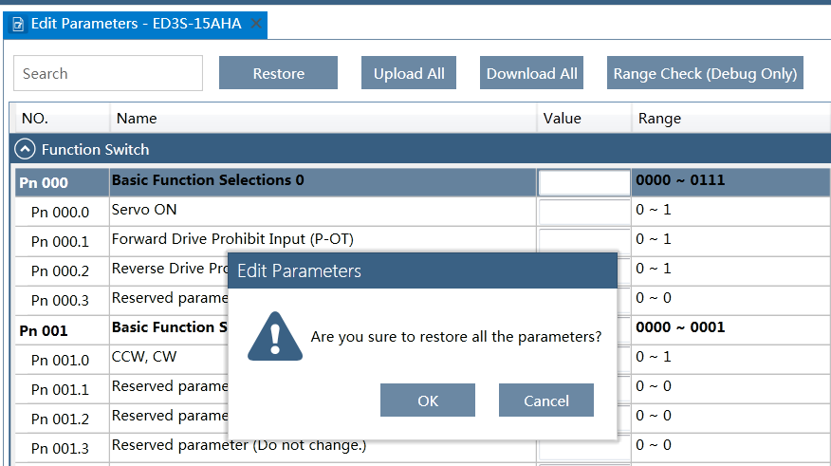
Users press button ”OK” ,then servo driver will restore all the parameters automatically as followings:

- Upload / Download parameters.
Users press button “Upload All”will read all the parameter indexes.
Users press button “Download All”will download all the displayed parameter indexes.

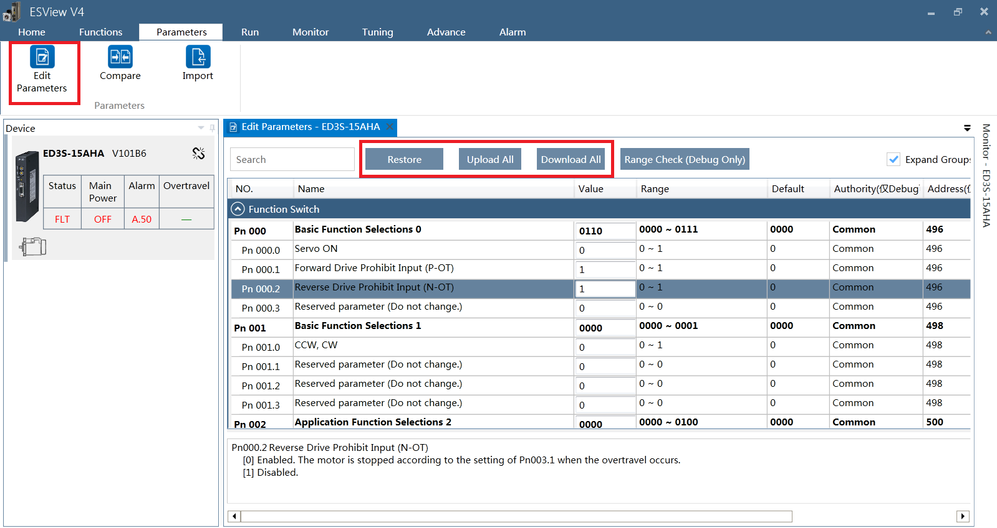

Users right-click the selected line ,then pop up window as followings
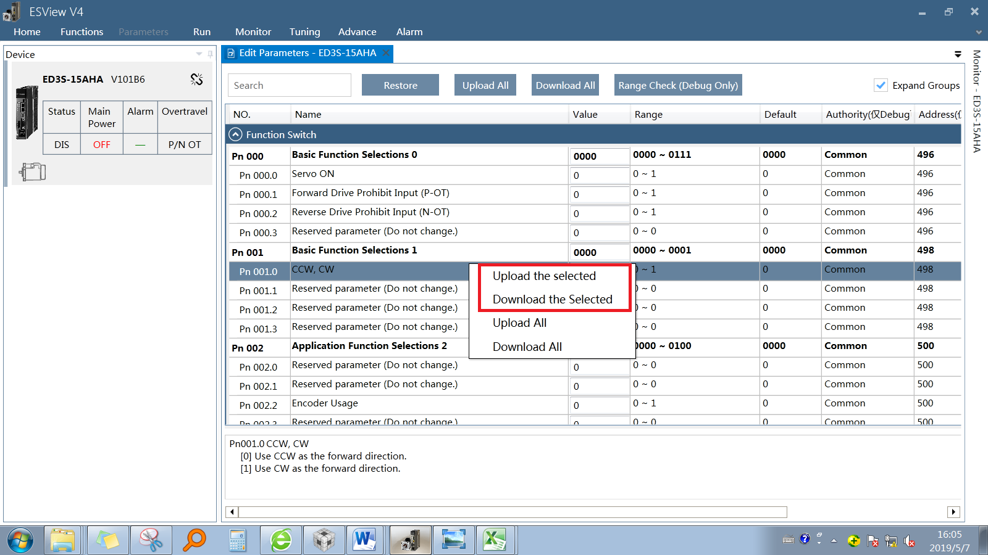

Then users can select Upload the selected/Download the selected.

3. Authority Management
MPV4 provided two levels of authority.The users of low authority are not allowed to see some manufacture private parameters.Relatively, the users of high authority are allowed to see and edit all the parameters.The high authority can be obtained by insert the right password. The authority management should be fulfilled on MPV4.

When users insert the wrong password and Click “Confirm”, window as followings will be pop up.

If the password is right , window will be
At the same time, MPV4 will write the correct password to the corresponding index. Servo driver will change the authority to high level.If the “Edit Parameter” window is still displayed, it will be automatically changed.

Tips:
- The right password user inserted is different from the password that Motion Perfect sends to servo.
- It is not necessary for Motion Perfect to know whether the servo driver is in advanced status or not.

相关算法 algorithm
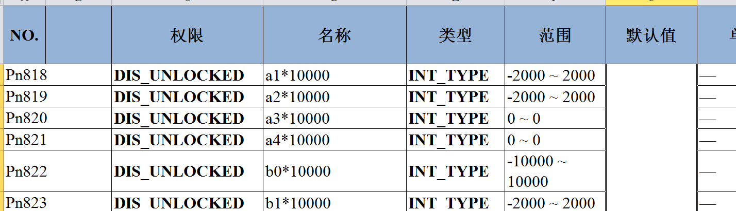
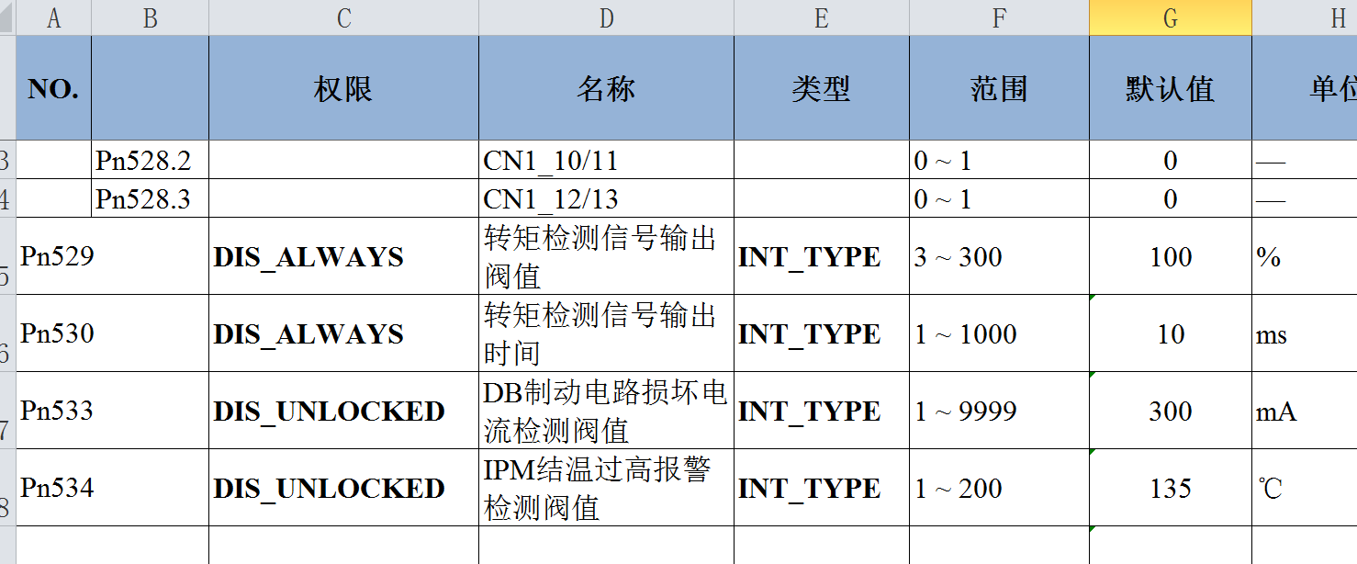

Table above is from <Drive Parameter Table>. There are two types of authority. “DIS_ALWAYS” means this parameter will be displayed no matter the authority is high or low. “DIS_UNLOCKED” means this parameter will only be displayed for advanced users.

关键技术点及风险点 key technologies and risks
- Whether the password user inserted is right is judged by MPV4 rather than servo driver.
- When users press “Restore”, MPV4 only send restore command to servo. Which parameters will be restored and what are the default values are determined by servo.

伺服状态监控 Servo Status Monitor

功能描述function description
Servo system status display,Includingalarm,power on /off,and so on. Servo system information is displayed in Esview V4. Will we substituteEtherCAT state machine for servo system status?

期望目标function details definition

详细通讯对象 communication objects details
Name | Index | Sub-index | Access | Value
驱动器状态数据  Drive state bits and state flags | 0x30A4 |  | RO | Drive state bits and state flags：  Bit0：POT  Bit1：NOT  Bit2：reserved  Bit3：ClearPulse Error counter  Bit4：reserved  Bit5：Main Power  Bit8：Servo Ready  Bit9: Restore finish flag  （Write 0 to clear this flag）  Bit10: Son  Bit11-Bit14：Servo state machine  [0] Not ready.  [1] switch on disable  [2] ready and switch on  [3] run  [4] Quick stop active  [5] MainPow offstop  [6] Fault reaction active  [7] Fault  [8] fault occur in not ready state  [9] STO active deal  Bit15：Have alarm
Reserved | 0x30A5-0x30FF | Reserved | RO | Reserved

通讯流程图 communication flow chart
Servo status displayed on Esview V4 as followings,
Status：NRY、FLT、RDY、DIS、RUN、STP、SAF
Main Power：ON、OFF
Alarm：A.xx、-
Overtravel：P/N OT、POT、NOT、-

A.xx mains the alarm number is xx, such as A.50。

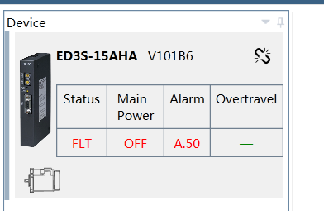

Status displayed on MPV4 may be different from Esview.

相关算法 algorithm
//

关键技术点及风险点 key technologies and risks
Will we substituteEtherCAT state machine for servo system status?

数据监控/IO监控 Data / IO Monitor

功能描述function description

期望目标function details definition

详细通讯对象 communication objects details
Name | Index | Sub-index | Access | Value | Data Type
Un监控数据  Un category monitor data | 0x3040-0x30A3 |  | RO
Motor rotated speed | 0x3040 |  | RO | Unit is rpm. | Signed Integer 16
reserved | 0x3041 |  | RO | Reserved.
reserved | 0x3042 |  | RO | Reserved.
内部扭矩指令百分比  Inner torque command percent | 0x3043 |  | RO | Unit is %. | Signed Integer 16
编码器旋转角脉冲数  Encoder rotated angle pulse unit value | 0x3044 |  | RO | Return 32bit encoder rotated angle pulse unit value. | Unsigned Integer 32
DI输入信号监视  DI input signals monitor | 0x3045 |  | RO |  | Unsigned Integer 16
TouchProbe信号状态监控位，第二编码器ABC监控位，STO输入信号监控位  TouchProbe、Second encoder and STO signals monitor | 0x3046 |  | RO | TouchProbe信号状态监控位：  Bit0：STO输入信号监控位HWBB1  Bit1：STO输入信号监控位HWBB2  Bit2：保留  Bit3：第二编码器C相监控位  Bit4：第二编码器B相监控位  Bit5：第二编码器A相监控位  Bit6：TouchProbe1信号状态监控位  Bit7：TouchProbe2信号状态监控位 | Unsigned Integer 16
DO输出信号监视  DI output signals monitor | 0x3047 |  | RO |  | Unsigned Integer 16
电机转过的脉冲数低位  Motor rotated position pulse unit value low 32bit | 0x3049 | 1 | RO | All parts of motor rotated position pulse unit value can be obtained by read 2 sub-index of 0x3049.  Joint as followings:  Value= (High <<32)++Low | Unsigned Integer 32
电机转过的脉冲数中低位  Motor rotated position pulse unit value high 32bit | 0x3049 | 2 | RO |  | Unsigned Integer 32
偏差脉冲计数器低位  Pulse Error counter | 0x304B | 1 | RO | Return 32bit pulse error counter value. | Unsigned Integer 32
给定脉冲计数器低位  Pulse command counter low 16bit | 0x304D | 1 | RO | All parts of pulse command counter value can be obtained by read 2 sub-index of 0x304D.  Joint as followings:  Value= (High <<32)++Low | Unsigned Integer 32
给定脉冲计数器中低位  Pulse command counterhigh32bit | 0x304D | 2 | RO |  | Unsigned Integer 32
负载惯量百分比  Load inertia Percent | 0x304F |  | RO | Unit is %. | Unsigned Integer 16
电机过载比率  Motor overload rate | 0x3050 |  | RO | Unit is %. | Unsigned Integer 16
母线电压  DC bus voltage | 0x3053 |  | RO | Unit is voltage. | Unsigned Integer 16
编码器温度  Encoder temperature | 0x3055 |  | RO | Unit is ℃ | Signed Integer 16
功率板温度  Power board temperature | 0x3056 |  | RO | Unit is ℃ | Signed Integer 16
外部编码器反馈计数低位  Second encoder counter low 32bit | 0x3057 | 1 | RO | All parts of second encoder counter value can be obtained by read 2 sub-index of 0x3057.  Joint as followings:  Value= (High << 32) +Low | Unsigned Integer 32
外部编码器反馈计数高位  Second encoder counter high32bit | 0x3057 | 2 | RO |  | Unsigned Integer 32
High authority displayed data | 0x3068-0x307D |  | RO | All the data among 0x3068-0x307D only displayed when users get high authority.
Actual torque percent | 0x3068 |  | RO | Uint is %. | Signed Integer 16
Iqr current percent | 0x3069 |  | RO | Uint is %. | Signed Integer 16
Control board temperature | 0x306B |  | RO | Unit is ℃ | Signed Integer 16
IPM temperature | 0x306C |  | RO | Unit is ℃ | Signed Integer 16
Netx chip temperature | 0x306D |  | RO | Unit is ℃ | Signed Integer 16
ISR max code time | 0x306E |  | RO | Unit is us | Unsigned Integer 16
ISR real-time code time | 0x306F |  | RO | Unit is us | Unsigned Integer 16
CLA max code time | 0x3070 |  | RO | Unit is us | Unsigned Integer 16
CLA real-time code time | 0x3071 |  | RO | Unit is us | Unsigned Integer 16
Low voltage torque limit | 0x3072 |  | RO | Unit is 0.01Nm | Unsigned Integer 16
UVW alarm record | 0x3073 |  | RO |  | Unsigned Integer 16
Motor rotator elec-angle | 0x3074 |  | RO |  | Signed Integer 16
Full closed loop position deviation | 0x3075 |  | RO |  | Signed Integer 32
Second encoder speed | 0x3076 |  | RO | rpm | Signed Integer 32
NetX chip over temperature count | 0x3077 |  | RO |  | Unsigned Integer 32
Background run time count 1 | 0x307A |  | RO | Unit is us | Unsigned Integer 16
Background run time count 2 | 0x307B |  | RO | Unit is us | Unsigned Integer 16
Line Break Count Max | 0x307C |  | RO |  | Unsigned Integer 32
Line Break Flag Count | 0x307D |  | RO |  | Signed Integer 16
 |  |  | RO

通讯流程图 communication flow chart
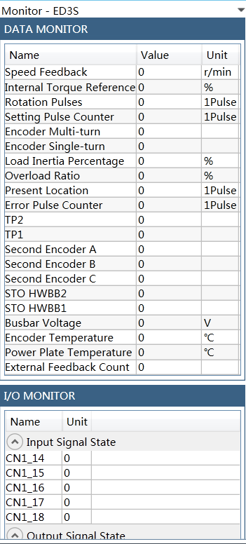

相关算法 algorithm
//

关键技术点及风险点 key technologies and risks
- Index 0x3062-0x307Fare only displayed when users insert right password and get high authority. For low authority users, they are all not allowed to display.
- Parts of indexes contain sub-index, MPV4 have to joint all the parts correctly to get the final data.

报警显示功能 Alarm Display

功能描述function description
MPV4能够实时显示伺服系统当前的报警ID、描述以及对应的解决办法等信息。
MPV4能够显示10组历史报警ID、描述以及对应的解决办法等信息。
用户可以通过电机界面上的按钮来清除伺服系统当前报警和历史报警记录。
高级权限下可以显示子报警ID，目前Esview V4尚无此功能，需要在MPV4中增加此功能。

MPV4 should be able to display the current alarm ID , description, and Solutions;
MPV4 should be able to display 10 alarm logs , including ID, description, and Solutions;
Users can clear the current alarm and all the alarm logs by two buttons on the MPV4 user interface.
Sub-ID can be displayed on MPV4 with high authority. This function is not included in Esview V4. However, it should be considered in project of Combo.

期望目标function details definition

详细通讯对象 communication objects details
Name | Index | Sub-index | Access | Value
Alarm function | 0x3681 | 01h | RO | Present alarm number  00h: no alarm  xxh: alarm number
Alarm function | 0x3681 | 02h | RO | Present sub-alarm number  xxh: alarm number
Alarm function | 0x3681 | 03h~0Ch | RO | Alarm log index  0~9  There are 10 alarm logs in each servo.  Read every index will return 32-bit data. The high 16bit means sub-alarm ID, and the low 16bit means alarm ID.
Alarm function | 0x3681 | 0Dh | RW | Clear present alarm  0: no action  1: try to clear present alarm
Alarm function | 0x3681 | 0Eh | RW | Clear all alarm logs  0: no action  1: try to clear alarm logs

通讯流程图 communication flow chart
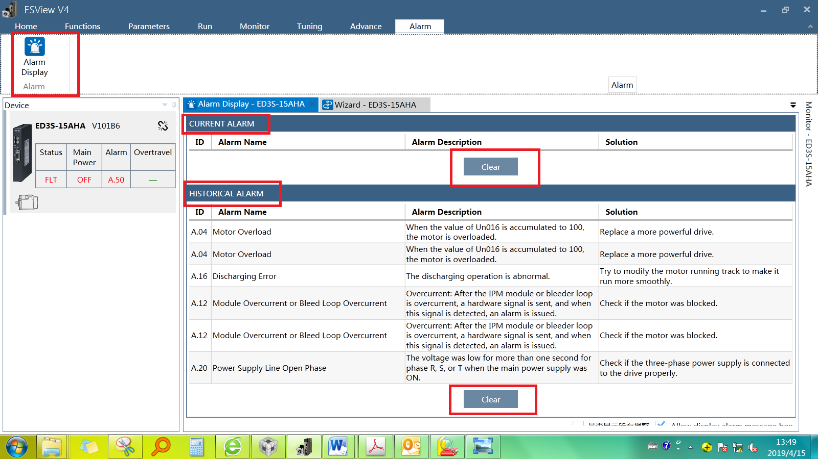

- About Sub-ID:
Sub-ID mains more detailed information. Every alarm ID contains one or more Sub-IDs.Sub-ID only be displayed with high authority.

MPV4 gets alarm ID and Sub-ID from servo driver. Alarm descriptions and solutions are stored in MPV4.

Sub-IDs are not displayed on Esview V4. MPV4 may consider it.

- Alarm log
Alarm log records the newest 10 alarms. If new alarm occurs on servo driver, alarm log will update automatically. Accordingly, if MPV4 read new alarm, it should get new alarm log from servo driver and update the window display.

- Clear present alarm

- Clear historical alarm
Clear alarm log.

相关算法 algorithm
//

关键技术点及风险点 key technologies and risks
//

ABS encoder操作ABS Encoder Operation

功能描述function description
MPV4 allows users to clear encoder multi-turn information and errors, and clear encoder inner error information by pressing two buttons on the MPV4 user interface.

期望目标function details definition

详细通讯对象 communication objects details
Name | Index | Sub-index | Access | Value
ABS encoder Clear errs | 0x3685 | 01h | RW | Clear all encoder errors  0:no action  1: write 1 will clear all encoder errors if servo is not in ”OPERATION” state.  Other: invalid
ABS encoder Clear errs | 0x3685 | 02h | RW | Clear multi-loop errors  0:no action  1: write 1 will clear encoder multi-looperrors if servo is not in ”OPERATION” state.  Other: invalid
ABS encoder information | 0x3001 | 01h | RO | Abs or inc type encoder  [0] Incremental encoder  [1]Absolute encoder
ABS encoder information | 0x3001 | 02h | RO | Encoder single loop resolution bit.  If servo return 20, it means the encoder resolution is 2^20.
ABS encoder information | 0x3001 | 03h | RO | Encoder multi loop resolution bit.  If servo return 16, it means the encoder resolution is 2^16.

通讯流程图 communication flow chart
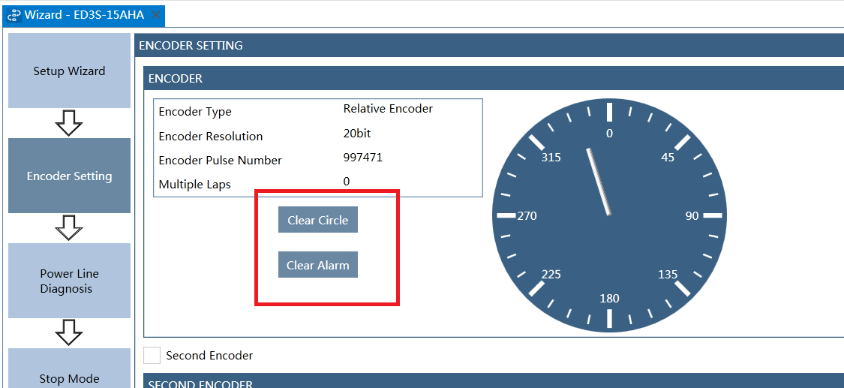
1. Clear encoder multi-loop errors
Write 1 to index 3685 (02h) will clear encoder multi-loop errors if servo is not in ”OPERATION” state. When users press button ”Clear Circle”, MPV4 should determine whether the servo status is “SON”. If the servo status is “SON”, no clear-command will be sent to servo.

2. Clear encoder innererrors
Write 1 to index 3685 (01h) will clear all encoder inner errors if servo is not in ”OPERATION” state. When users press button ”Clear Alarm”, MPV4 should determine whether the servo status is “SON”. If the servo status is “SON”, no clear-command will be sent to servo.

3. Encoder information display.
Index 0x3001 provided encoder type, single loop resolution, multi loop resolution.
Motion Perfect may display more alternative information by read index 0x3040-0x30A3. It is the same as data monitor function block.

相关算法 algorithm
//

关键技术点及风险点 key technologies and risks
//

Tuning-less mode

功能描述function description
Tuning-less mode is easy to use and has low servo rigidity relatively but good disturbance (unknown load inertia or torque) rejection performance. It can be used for out-of-box tuning, but may not meet high demand applications.
In default, the servo drive works in tuning-less mode (Pn100.0 is set to 1). In this mode, we don’t need to modify the following parameters. And the corresponding parameters in Pn table are invalid.
Pn101 | Response Frequency Level (Servo rigidity)
Pn102 | Speed Loop Gain
Pn103 | Speed Loop Integral Time
Pn104 | Position Loop Gain
Pn105 | Torque Reference Filter Time Constant
Pn106 | Moment of Inertia Ratio

期望目标function details definition

详细通讯对象 communication objects details
Name | Index | Sub-index | Access | Value
TUNE_AUTONOTCH_EN_ADDR | 0x3690 | 0x01 | RW | 0: DisableOnline Vibration Suppression function;  1: Enable;
TUNE_TUNING_MODE_ADDR | 0x3690 | 0x03 | RW | 1: Tuning-less mode;  2: One-parameter auto-tuning mode 1;  3: One-parameter auto-tuning mode 2;  4: Manual tuning mode 1;  5: Manual tuning mode 2;
TUNE_AUTOTUNE_STATE_ADDR | 0x3691 | 0x02 | RO | Bit 0: AutoTuning;  1: Parameter auto-tuning tool is active.  Bit 4: AutoTuningSon;  1: Motor is power on.  Bit 5: Start;  1: The tuning process is started.  Bit 6: Calc;  1: The trajectory parameters have been calculated.  Bit 7: Save;  1: The results have been saved to Pn table.  Bit 8: Finish;  1: The tuning process is over.  Bit 9: Fail;  1: The results are unavailable.  Bit 10: NotchValid;  1: Notch is valid for vibrations.  Bit 11: AFilterValid;  1: AFilter is valid for vibrations.
Pn136Servo rigidity | 0x31EC |  | RW | The servo rigidity of tuning-less mode.
Pn137DOB bandwidth | 0x31ED |  | RW | The bandwidth of the disturbance observer only used for tuning-less mode.
Pn138Disturbance compensation percentage | 0x31EE |  | RW | The compesation percentage of observed disturbance only used for tuning-less mode.
Pn139Load inertia percentage | 0x31EF |  | RW | Load inertia percentage only used for tuning-less mode.
Pn140Torque command filter time constant | 0x31F0 |  | RW | Torque command filter time constant only used for tuning-less mode.

通讯流程图 communication flow chart
- Popup window 1
Cautions.
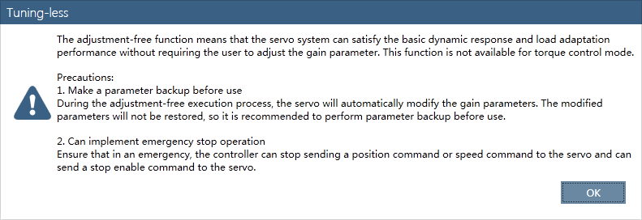
- Popup window 2
If the current tuning mode is not tuning-less mode (Pn100.0 is not 1), the host will write 1 to Pn100.0 and give a popup window to notify the user to restart the servo drive.
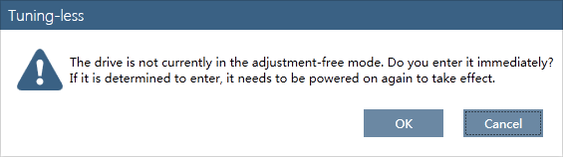
- Popup window 3
Because tuning-less mode, one-parameter auto-tuning mode, manual tuning mode determined by Pn100.0 are all invalid when using parameter auto-tuning tool. So the following window popupswhen the parameter auto-tuning tool is active.
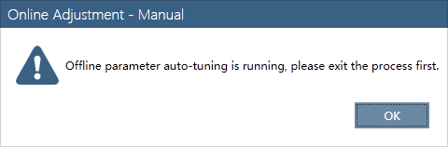
- Main window 1.
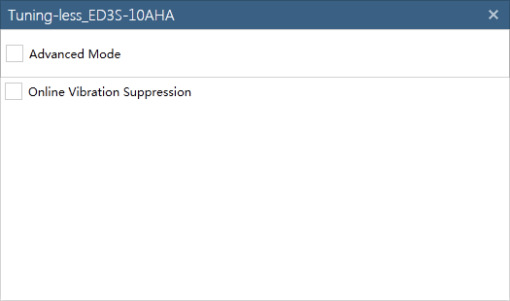
- Main window 2.
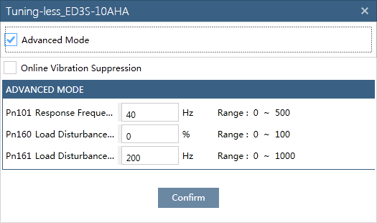
Note: Pn101, Pn160, Pn161 will be replacedwith Pn136~Pn140 in the following version.
- The flow chart.

相关算法 algorithm
//

关键技术点及风险点 key technologies and risks
//

One-parameter auto-tuning mode

功能描述function description
One-parameter auto-tuning mode is easy to use and can meet high demand applications, one-parameter refers to Pn101 servo rigidity. In this mode, Pn106 load inertia should be set manually.
The servo drive works in One-parameter auto-tuning mode when Pn100.0 is set to 3. In this mode, we don’t need to modify the following parameters. And the corresponding parameters in Pn table are invalid.
Pn102 | Speed Loop Gain
Pn103 | Speed Loop Integral Time
Pn104 | Position Loop Gain
Pn105 | Torque Reference Filter Time Constant

期望目标function details definition

详细通讯对象 communication objects details
Name | Index | Sub-index | Access | Value
TUNE_AUTONOTCH_EN_ADDR | 0x3690 | 0x01 | RW | 0: DisableOnline Vibration Suppression function;  1: Enable;
TUNE_TUNING_MODE_ADDR | 0x3690 | 0x03 | RW | 1: Tuning-less mode;  2: One-parameter auto-tuning mode 1;  3: One-parameter auto-tuning mode 2;  4: Manual tuning mode 1;  5: Manual tuning mode 2;
TUNE_TUNING_DAMPING_ADDR | 0x3690 | 0x04 | RW | 0: Standard;  1: Stable;
TUNE_AUTOTUNE_STATE_ADDR | 0x3691 | 0x02 | RO | Bit 0: AutoTuning;  1: Parameter auto-tuning tool is active.  Bit 4: AutoTuningSon;  1: Motor is power on.  Bit 5: Start;  1: The tuning process is started.  Bit 6: Calc;  1: The trajectory parameters have been calculated.  Bit 7: Save;  1: The results have been saved to Pn table.  Bit 8: Finish;  1: The tuning process is over.  Bit 9: Fail;  1: The results are unavailable.  Bit 10: NotchValid;  1: Notch is valid for vibrations.  Bit 11: AFilterValid;  1: AFilter is valid for vibrations.
Pn101 Servo rigidity | 0x31C9 |  | RW | This parameter determines the response characteristic of the servo system.  Increase this setting for improving the response characteristic of the servo system; decrease this setting if the vibration was occurred.

通讯流程图 communication flow chart
- Popup window 1
Cautions.
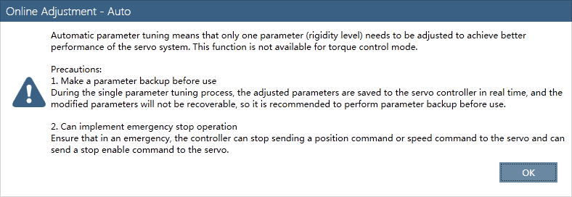
- Popup window 2
If the current tuning mode is not one-parameter auto-tuning mode (Pn100.0 is not 3), the host will write 3 to Pn100.0 and give a popup window to notify the user to restart the servo drive.
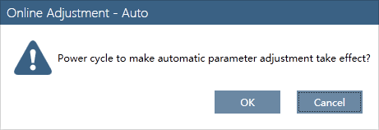
- Popup window 3
Because tuning-less mode, one-parameter auto-tuning mode, manual tuning mode determined by Pn100.0 are all invalid when using parameter auto-tuning tool. So the following window popups when the parameter auto-tuning tool is active.
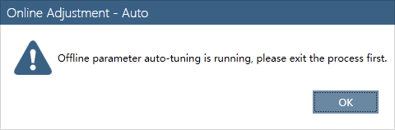
- Main window 1.

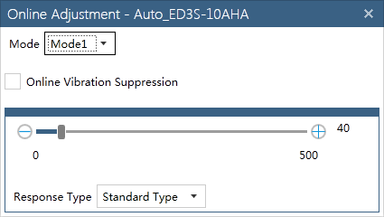
- Main window 2.
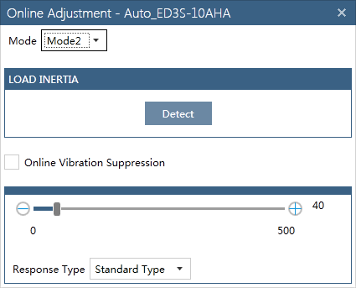
- The flow chart.

相关算法 algorithm
//

关键技术点及风险点 key technologies and risks
//

Manual tuning mode

功能描述function description
Manual tuning mode is the most complex and need to set all the following parameters manually (Pn101 servo rigidity is not used).
Pn102 | Speed Loop Gain
Pn103 | Speed Loop Integral Time
Pn104 | Position Loop Gain
Pn105 | Torque Reference Filter Time Constant
Pn106 | Moment of Inertia Ratio
Manual tuning is usually used by expert users when tuning-less or one-parameter auto-tuning can’t meet the performance demand.
The servo drive works in manual tuning mode when Pn100.0 is set to 5.

期望目标function details definition

详细通讯对象 communication objects details
Name | Index | Sub-index | Access | Value
TUNE_AUTONOTCH_EN_ADDR | 0x3690 | 0x01 | RW | 0: DisableOnline Vibration Suppression function;  1: Enable;
TUNE_GAIN_SWITCH_EN_ADDR | 0x3690 | 0x02 | RW | 0: Always be gain settings 1;  2: Use the torque reference as the condition (level setting: Pn117);  3: Use the position deviation as the condition (level setting: Pn118);  4: Use the acceleration as the condition (level setting: Pn119);  5: Use the speed reference as the condition (level setting: Pn120);  6: Use the position reference as the condition (level setting: Pn123);  7: Use the actual speed of the motor as the condition (level setting: Pn124);  8: Both use the position reference (Pn123) and actual speed of the motor (Pn124) as the condition;  9: Always be gain settings 2;  10: When the positioning is completed.
TUNE_TUNING_MODE_ADDR | 0x3690 | 0x03 | RW | 1: Tuning-less mode;  2: One-parameter auto-tuning mode 1;  3: One-parameter auto-tuning mode 2;  4: Manual tuning mode 1;  5: Manual tuning mode 2;
TUNE_MUNUAL_TUNING_CFG_ADDR | 0x3690 | 0x05 | RO | Bit 0~2: CtrlMode;  0: Position control;  1: Velocity control;  2: Torque control.  Bit 3: AutoNotch;  1: Online Vibration Suppression function is active.  Bit 4~7: GainSwitchMode;  See object “TUNE_GAIN_SWITCH_EN_ADDR”.  Bit 8:ModelFellowCtrl;  1: Model fellow control is active.  Bit 9: FullClosedCtrl;  1: Full closed control is active.  Bit 10: EtherCAT;  1: Servo drive is controlled by EtherCAT master. (Fixed to 1in Combo)
TUNE_AUTOTUNE_STATE_ADDR | 0x3691 | 0x02 | RO | Bit 0: AutoTuning;  1: Parameter auto-tuning tool is active.  Bit 4: AutoTuningSon;  1: Motor is power on.  Bit 5: Start;  1: The tuning process is started.  Bit 6: Calc;  1: The trajectory parameters have been calculated.  Bit 7: Save;  1: The results have been saved to Pn table.  Bit 8: Finish;  1: The tuning process is over.  Bit 9: Fail;  1: The results are unavailable.  Bit 10: NotchValid;  1: Notch is valid for vibrations.  Bit 11: AFilterValid;  1: AFilter is valid for vibrations.

Pn parameters:
Name | Index | Sub-index | Access | Value
Pn005.2 Torque Feedforward Method | 0x3169
Pn005.3 Speed Feed forward Method | 0x3169
Position control:
Pn104 Position Loop Gain | 0x31CC
Speed feed forward:
Pn112 Speed Feedforward | 0x31D4
Pn113 Speed Feedforward Filter Time Constant | 0x31D5
Model Tracking Control:
Pn151 Model Following Control Gain | 0x31FB
Pn155 Anti-Resonance Frequency for Jitter Suppression | 0x31FF
Speed control:
Pn102 Speed Loop Gain | 0x31CA
Pn103 Speed Loop Integral Time | 0x31CB
Pn106 Moment of Inertia Ratio | 0x31CE
Torque feed forward:
Pn114 Torque Feedforward | 0x31D6
Pn115 Torque Feedforward Filter Time Constant | 0x31D7
Speed filter:
Pn135 Speed Feedback Filter Time | 0x31EB
Torque filter:
Pn105 Torque Reference Filter Time Constant | 0x31CD
Torque limit:
Pn401 Forward Internal Torque Limit | 0x32F5
Pn402 Reverse Internal Torque Limit | 0x32F6
Notch filter:
Pn181 Notch Filter Frequency 1 | 0x3219
Pn182 Notch Filter Depth 1 | 0x321A
Pn183 Notch Filter Width 1 | 0x321B
Pn184 Notch Filter Frequency 2 | 0x321C
Pn185 Notch Filter Depth 2 | 0x321D
Pn186 Notch Filter Width 2 | 0x321E
Pn187 Notch Filter Frequency 3 | 0x321F
Pn188 Notch Filter Depth 3 | 0x3220
Pn189 Notch Filter Width 3 | 0x3221
Anti-resonance filter:
Pn173 Vibration Suppression Frequency at Intermediate-Frequency | 0x3211
Pn175 Vibration Suppression Damping Gain at Intermediate-Frequency | 0x3213
Mixed Deviation Calculation & Alarm:
Pn213 Position Deviation Overflow Warning Level at Fully Closed-loop Control | 0x3239
Pn214 Position Deviation Reset Level at Fully Closed-loop Control | 0x323A
Gain Switching:
Pn122 Gain Switching Waiting Time | 0x31DE
Pn123 Gain Switching Level | 0x31DF
Pn124 Actual Speed Threshold | 0x31E0
Pn125 Position Gain Switching Time | 0x31E1
Pn126 Gain Switching Hysteresis | 0x31E2

通讯流程图 communication flow chart
- Popup window 1
Cautions.
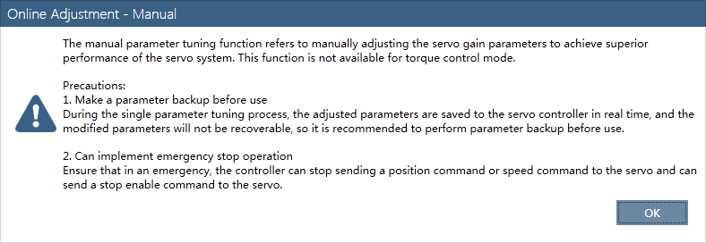
- Popup window 2
If the current tuning mode is not manual tuning mode (Pn100.0 is not 5), the host will write 5 to Pn100.0 and give a popup window to notify the user to restart the servo drive.
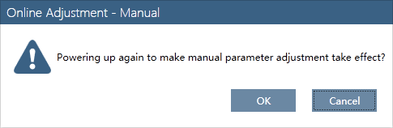
- Popup window 3
Because tuning-less mode, one-parameter auto-tuning mode, manual tuning mode determined by Pn100.0 are all invalid when using parameter auto-tuning tool. So the following window popups when the parameter auto-tuning tool is active.
- Main window 1. Mode 1, there’s no Detect button.
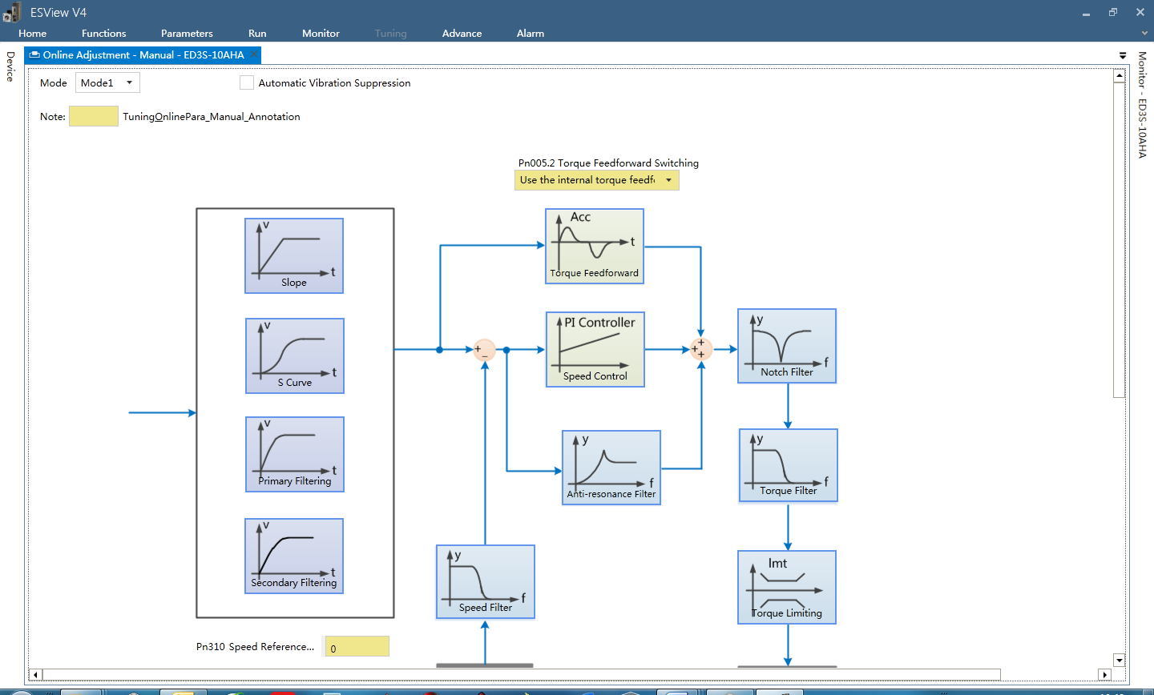
- Main window 2. Mode 2, there’s a Detect button.
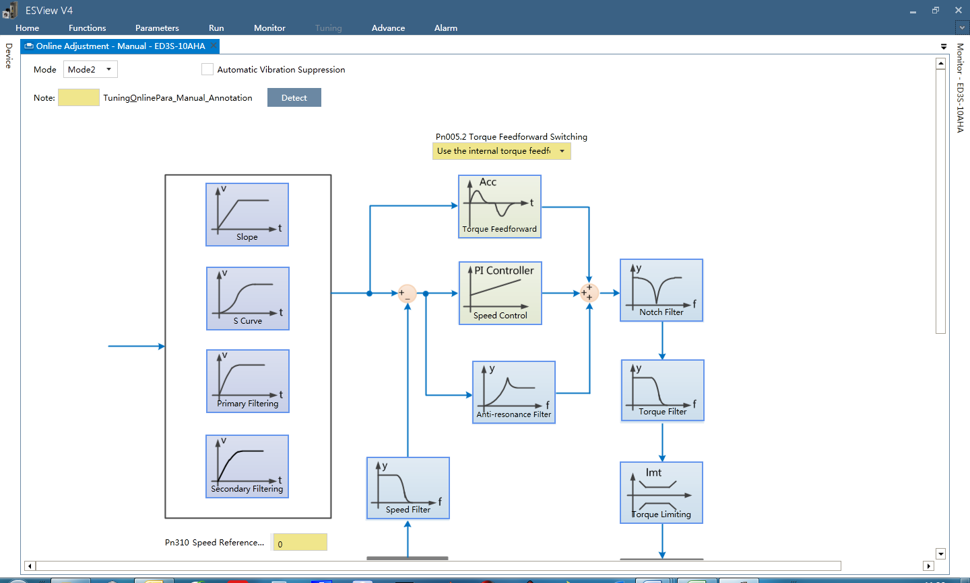
- If the control mode (read from TUNE_MUNUAL_TUNING_CFG_ADDR) is changed (e.g. modify object 0x6060), the following window will pop-up, click OK will load corresponding UI according to the new control mode.
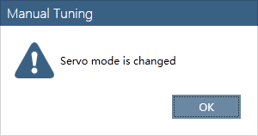
- The flow chart.

相关算法 algorithm
- UI selection
The UI figures used in ESVIEW V4 are all in the visio file.
Read object TUNE_MUNUAL_TUNING_CFG_ADDR, and load corresponding UI according to the table.
CtrlMode  Bit2:0 | GainSwitchMode  Bit7:4 | ModelFollowCtrl  Bit8 | FullClosed  Bit9 | UI
0 | 0 | 0 | 0 | Fig8
0 | 1 or10 | 0 | 0 | Fig5+Fig8
0 | 2~7 | 0 | 0 | Fig6+Fig8
0 | 8 | 0 | 0 | Fig7+Fig8
0 | 9 | 0 | 0 | Fig8
0 | 0 | X | 1 | Fig10
0 | 1 or10 | X | 1 | Fig5+Fig10
0 | 2~7 | X | 1 | Fig6+Fig10
0 | 8 | X | 1 | Fig7+Fig10
0 | 9 | X | 1 | Fig10
0 | 0 | 1 | 0 | Fig11
0 | 1 or10 | 1 | 0 | Fig5+Fig11
0 | 2~7 | 1 | 0 | Fig6+Fig11
0 | 8 | 1 | 0 | Fig7+Fig11
0 | 9 | 1 | 0 | Fig11
1 | X | X | X | Fig9
2 | X | X | X | No UI
- Automatic Vibration Suppression
If the check box is selected, some parameters of Notch filter and Anti-resonance filter should be read only. (Pn184, Pn185, Pn186, Pn173, Pn175)
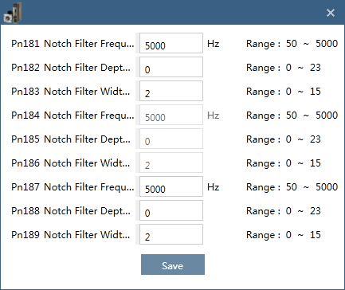
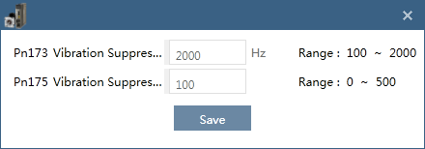
- Gain Switching
1. If the check box is unselected or if the check box is selected and choose Fixed to the first set of gains, the parameters under some blocks are (list in 3.10.3)
Position Control block parameter is Pn104,
Speed Control block parameters are Pn102, Pn103, Pn106,
Torque Filter block parameter is Pn105.
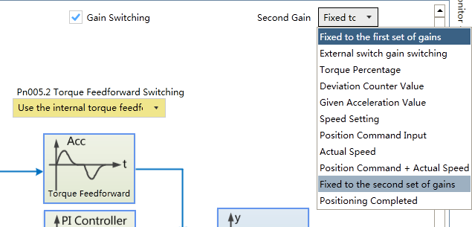
2. If the check box is selected and choose Fixed to the second set of gains, the parameters under some blocks are changed.
Position Control block parameter is Pn109,
Speed Control block parameters are Pn107, Pn108, Pn106,
Torque Filter block parameter is Pn110.
Name | Index | Sub-index | Access | Value
Pn107 Second Speed Loop Gain | 0x31CF
Pn108 Second Speed Loop Integral Time | 0x31D0
Pn109 Second Position Loop Gain | 0x31D1
Pn110 Second Torque Reference Filter Time Constant | 0x31D2

3. If the check box is selected and choose the other options, the parameters under some blocks are changed too.
Position Control block parameters are Pn104, Pn109,
Speed Control block parameters are Pn102, Pn103, Pn107, Pn108, Pn106,
Torque Filter block parameters are Pn105, Pn110.
- Model Fellow Control
If “Fig11” is selected, means the Model Fellow Control is active. Some parameters should be changed.
Speed Feed forwardblock parameter is Pn153,
Torque Feed forwardblock parameter is Pn154.
Name | Index | Sub-index | Access | Value
Pn153 Model Following Control Speed Feedforward Coefficient | 0x31FD
Pn154 Model Following Control Torque Feedforward Coefficient | 0x31FE

关键技术点及风险点 key technologies and risks
//

Parameter auto-tuning tool

功能描述function description
If tuning-less mode and one-parameter auto-tuning mode can’t meet the performance demand, manual tuning mode should be used. Parameter auto-tuning tool is helpful to adjust Pn102~Pn105 used in manual tuning mode.
When using this tool, Pn106 load inertia should be set accurately. Tuning-less mode, one-parameter auto-tuning mode, manual tuning mode determined by Pn100.0 are all invalid. The tool calculates the following parameters internally. And the corresponding parameters in Pn table are invalid.
Pn102 | Speed Loop Gain
Pn103 | Speed Loop Integral Time
Pn104 | Position Loop Gain
Pn105 | Torque Reference Filter Time Constant
The command (position) is feed by the servo drive internally.

期望目标function details definition

详细通讯对象 communication objects details
Name | Index | Sub-index | Access | Value
Drive state | 0x30A4 |  | RO | Bit 10: ServoOnState;  1: The motor is power on.  Bit 11~14: SvState;  0: Not ready state without faults;  1: The servo drive is initialized but disabled to run;  2: Ready to run;  3: Motor is running; (power on)  4: Motor is quick stopping;  5: Motor is stopping caused by power off;  6: Fault reaction;  7: Fault state;  8: Not ready state with faults;  9: STO reaction.
TUNE_ACC_TIME0_ADDR | 0x3686 | 0x03 | RO
TUNE_EVEN_TIME0_ADDR | 0x3686 | 0x04 | RO
TUNE_MAX_SPD0_ADDR | 0x3686 | 0x05 | RO
TUNE_ACC_TIME1_ADDR | 0x3686 | 0x06 | RO
TUNE_EVEN_TIME1_ADDR | 0x3686 | 0x07 | RO
TUNE_MAX_SPD1_ADDR | 0x3686 | 0x08 | RO
TUNE_AUTONOTCH_EN_ADDR | 0x3690 | 0x01 | RW | 0: DisableOnline Vibration Suppression function;  1: Enable;
TUNE_AUTOTUNE_CMD_ADDR | 0x3691 | 0x01 | RW | 1: Open the tool;  2: Servo on;  3: Servo off;  4: Start to move;  5: Save results;  6: Close the tool;  7: Calculate the motion trajectory.
TUNE_AUTOTUNE_STATE_ADDR | 0x3691 | 0x02 | RO | Bit 0: AutoTuning;  1: Parameter auto-tuning tool is active.  Bit 4: AutoTuningSon;  1: Motor is power on.  Bit 5: Start;  1: The tuning process is started.  Bit 6: Calc;  1: The trajectory parameters have been calculated.  Bit 7: Save;  1: The results have been saved to Pn table.  Bit 8: Finish;  1: The tuning process is over.  Bit 9: Fail;  1: The results are unavailable.  Bit 10: NotchValid;  1: Notch is valid for vibrations.  Bit 11: AFilterValid;  1: AFilter is valid for vibrations.
TUNE_AUTOTUNE_POSKP_ADDR | 0x3691 | 0x03 | RO | The current proportional gain of position loop.
TUNE_AUTOTUNE_KV_ADDR | 0x3691 | 0x04 | RO | The current servo rigidity of speed loop.
TUNE_AUTOTUNE_SPDKP_ADDR | 0x3691 | 0x05 | RO | The current proportional gain of speed loop.
TUNE_AUTOTUNE_SPDKI_ADDR | 0x3691 | 0x06 | RO | The current integral time of speed loop.
TUNE_AUTOTUNE_TF_ADDR | 0x3691 | 0x07 | RO | The current torque command filter time constant.
TUNE_AUTOTUNE_AF_ADDR | 0x3691 | 0x08 | RO | The frequency of vibration suppression filter (AFilter).
TUNE_AUTOTUNE_NOTCH1_ADDR | 0x3691 | 0x09 | RO | The frequency of notch filter 1.
TUNE_AUTOTUNE_NOTCH2_ADDR | 0x3691 | 0x0A | RO | The frequency of notch filter 2.
TUNE_AUTOTUNE_NOTCH3_ADDR | 0x3691 | 0x0B | RO | The frequency of notch filter 3.
Pn164PJOG0 Rotating revolutions | 0x3208 |  | RW | Can be positive or negative, unit rev.
Pn165PJOG0 Rotating Speed | 0x3209 |  | RW | Positive only, unit rpm.
Pn167PJOG0 Stop Time | 0x320B |  | RW | Unit ms.
Pn168PJOG1 Rotating revolutions | 0x320C |  | RW | Can be positive or negative, unit rev.
Pn169PJOG1 Rotating Speed | 0x320D |  | RW | Positive only, unit rpm.
Pn171PJOG1 Stop Time | 0x320F |  | RW | Unit ms.

通讯流程图 communication flow chart
- Popup window 1
Cautions.
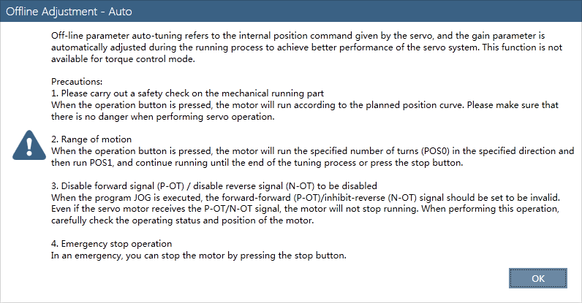
- Popup window 2
If the servo drive has entered to Fnxxx menu by the way of operating panel (4 keys and 5 LEDs), the Parameter auto-tuning tool can’t be used in ESVIEW, so the following window will popup. But it is unnecessary in Combo.
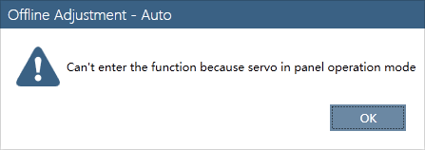
- Popup window 3
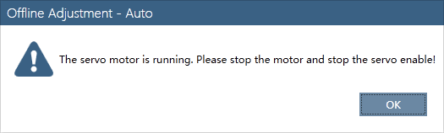
- Main window 1.
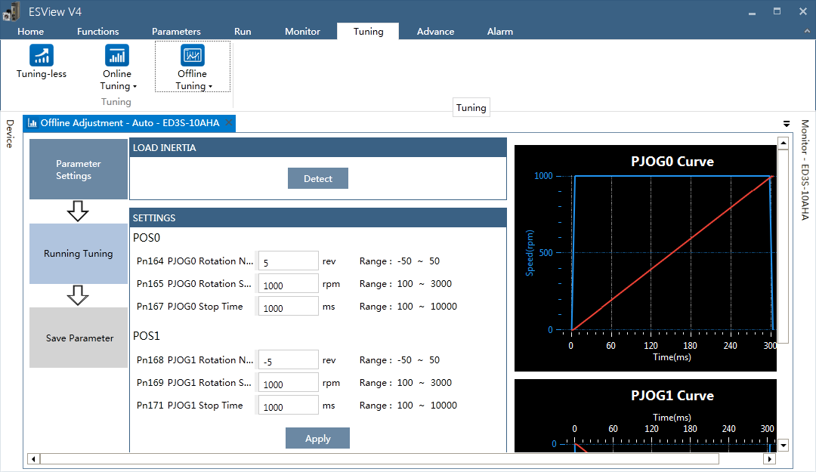
- Main window 2.
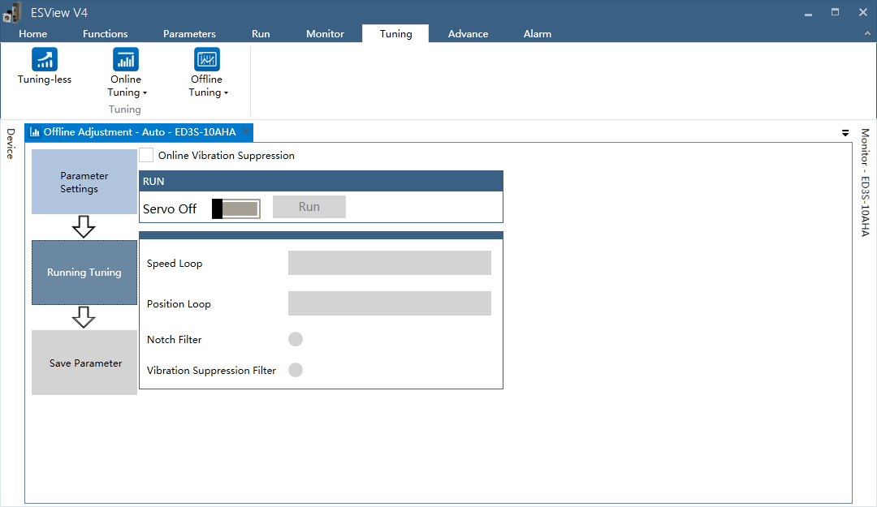
- Main window 3.
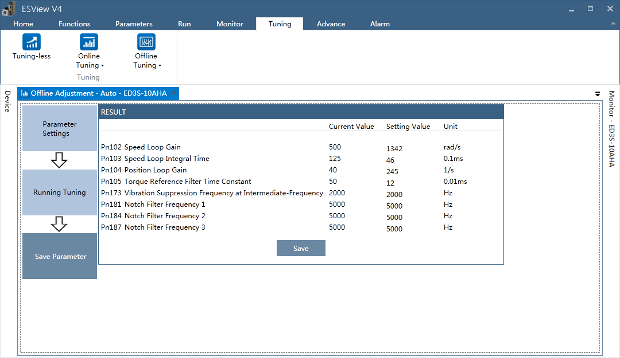
- Information for failure.

Probable causes:
- The servo motor is not mounted firmly, or the equipment is not stable.
- The rigidity of the equipment is too low, or there is a gap in the coupling.
- Too few turns, or the speed is too slow.
- Too much load or inertia on the shaft.
Advises:
- Check the mounting or coupling problems.
- Modify motion trajectory.
- Use Online Vibration Suppression function.
- Use Tuning-less Mode, One Parameter Auto Tuning Mode or Manual Tuning Mode.

- The flow chart.

相关算法 algorithm
Planned motion trajectory:

关键技术点及风险点 key technologies and risks
//

Load inertia identification tool

功能描述function description
Accurate load inertia is needed when adjust the servo parameters, except for tuning-less mode. Load inertia identification tool is used to measure the load inertia, and gives a percentage of load inertia to motor inertia finally.
When using this tool, tuning-less mode or one-parameter auto-tuning mode or manual tuning mode determined by Pn100.0 is valid. The command (speed) is feed by the servo drive internally.

期望目标function details definition

详细通讯对象 communication objects details
Name | Index | Sub-index | Access | Value
Drive state | 0x30A4 |  | RO | Bit 10: ServoState;  1: The motor is power on.  Bit 11~14: SvState;  0: Not ready state without faults;  1: The servo drive is initialized but disabled to run;  2: Ready to run;  3: Motor is running; (power on)  4: Motor is quick stopping;  5: Motor is stopping caused by power off;  6: Fault reaction;  7: Fault state;  8: Not ready state with faults;  9: STO reaction.
INERTIA_CMD_REG_ADDR | 0x3684 | 0x01 | RW | 1: Open the tool;  2: Servo on;  3: Servo off;  4: Start to move;  5: Save results;  6: Close the tool.
INERTIA_VAL_REG_ADDR | 0x3684 | 0x02 | RO | Result which can be saved to Pn106.
INERTIA_STATE_REG_ADDR | 0x3684 | 0x03 | RO | Bit 0: JMeas;  1: Load inertia identification is active.  Bit 4: JMeasSon;  1: Motor is power on.  Bit 5: Start;  1: The process is started.  Bit 7: Finish;  1: The process is over.  Bit 8: Save;  1: The result have been saved to Pn106.
Pn106 Load inertia percentage | 0x31CE |  | RW | = (Load moment of inertia at motor shaft / Servomotor moment of inertia) × 100%

通讯流程图 communication flow chart
- Popup window 1.
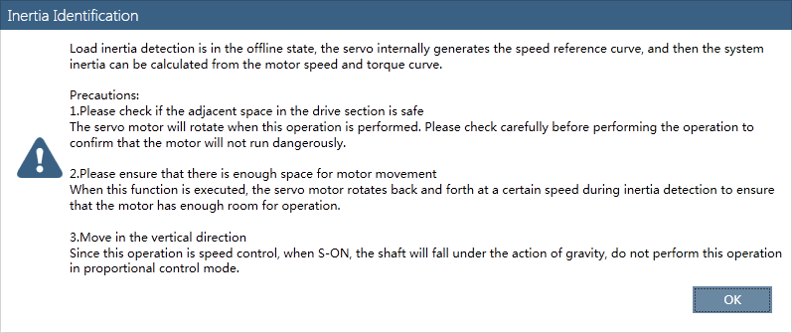
- Popup window 2.
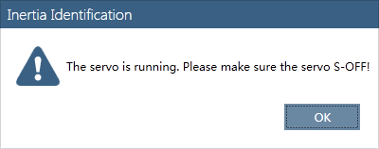
- Main window.

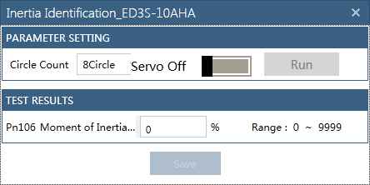
- The flow chart.

相关算法 algorithm
//

关键技术点及风险点 key technologies and risks
//

JOG

功能描述function description
JOG can be used for trial running (speed control mode).
When using this tool, tuning-less mode or one-parameter auto-tuning mode or manual tuning mode determined by Pn100.0 is valid. The speed command value is from Pn305 (>=0), and the direction is determined by the controller commands.

期望目标function details definition

详细通讯对象 communication objects details
Name | Index | Sub-index | Access | Value
Drive state | 0x30A4 |  | RO | Bit 10: ServoOnState;  1: The motor is power on.  Bit 11~14: SvState;  0: Not ready state without faults;  1: The servo drive is initialized but disabled to run;  2: Ready to run;  3: Motor is running; (power on)  4: Motor is quick stopping;  5: Motor is stopping caused by power off;  6: Fault reaction;  7: Fault state;  8: Not ready state with faults;  9: STO reaction.
JOG_CMD_ADDR | 0x3682 | 0x01 | WO | 0: Servo off;  1: Servo on;
JOG_FORWARD_ADDR | 0x3682 | 0x02 | WO | 0: Clear speed command to zero;  1: Set speed command to Pn305;
JOG_BACKWARD_ADDR | 0x3682 | 0x03 | WO | 0: Clear speed command to zero;  1: Set speed command to negative Pn305;
Pn305 JOG Speed | 0x3295 |  | RW | >=0, Unit rpm.
Pn306 Soft start acceleration time | 0x3296 |  | RW | The time from 0 to 1000rpm, unit ms.
Pn307 Soft start deceleration time | 0x3297 |  | RW | The time from 1000 to 0rpm, unit ms.

通讯流程图 communication flow chart
- Popup window 1
Cautions.
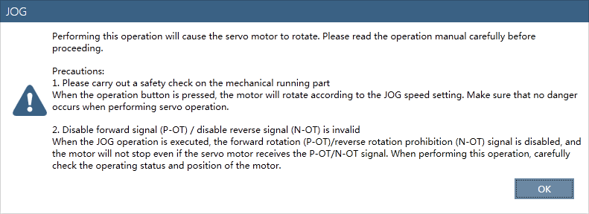
- Popup window 2
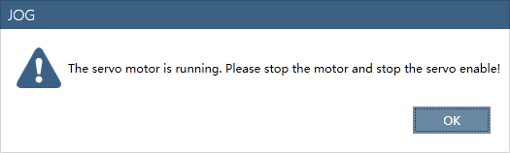
- Main window .
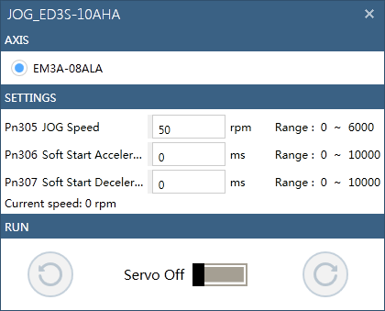
- The flow chart.

相关算法 algorithm

关键技术点及风险点 key technologies and risks
//

Program JOG

功能描述function description
Program JOG can be used for trial running (position control mode).
When using this tool, tuning-less mode or one-parameter auto-tuning mode or manual tuning mode determined by Pn100.0 is valid. The command (position) is feed by the servo drive internally.

期望目标function details definition

详细通讯对象 communication objects details
Name | Index | Sub-index | Access | Value
Drive state | 0x30A4 |  | RO | Bit 10: ServoOnState;  1: The motor is power on.  Bit 11~14: SvState;  0: Not ready state without faults;  1: The servo drive is initialized but disabled to run;  2: Ready to run;  3: Motor is running; (power on)  4: Motor is quick stopping;  5: Motor is stopping caused by power off;  6: Fault reaction;  7: Fault state;  8: Not ready state with faults;  9: STO reaction.
PJOG_CMD_ADDR | 0x3686 | 0x01 | RW | 1: Open the tool;  2: Servo on;  3: Servo off;  4: Start to move;  5: Reserved;  6: Close the tool;  7: Calculate the motion trajectory.
PJOG_STATE_ADDR | 0x3686 | 0x02 | RO | Bit 0: PJOG;  1: Program JOG tool is active.  Bit 4: PJOGSon;  1: Motor is power on.  Bit 6: Calc;  1: The trajectory parameters have been calculated.
TUNE_ACC_TIME0_ADDR | 0x3686 | 0x03 | RO
TUNE_EVEN_TIME0_ADDR | 0x3686 | 0x04 | RO
TUNE_MAX_SPD0_ADDR | 0x3686 | 0x05 | RO
TUNE_ACC_TIME1_ADDR | 0x3686 | 0x06 | RO
TUNE_EVEN_TIME1_ADDR | 0x3686 | 0x07 | RO
TUNE_MAX_SPD1_ADDR | 0x3686 | 0x08 | RO
Pn164PJOG0 Rotating revolutions | 0x3208 |  | RW | Can be positive or negative, unit rev.
Pn165PJOG0 Rotating Speed | 0x3209 |  | RW | Positive only, unit rpm.
Pn166PJOG0 Acc./Dec. time | 0x320A |  | RW | Unit ms.
Pn167PJOG0 Stop Time | 0x320B |  | RW | Unit ms.
Pn168PJOG1 Rotating revolutions | 0x320C |  | RW | Can be positive or negative, unit rev.
Pn169PJOG1 Rotating Speed | 0x320D |  | RW | Positive only, unit rpm.
Pn170PJOG1 Acc./Dec. time | 0x320E |  | RW | Unit ms.
Pn171PJOG1 Stop Time | 0x320F |  | RW | Unit ms.

通讯流程图 communication flow chart
- Popup window 1
Cautions.
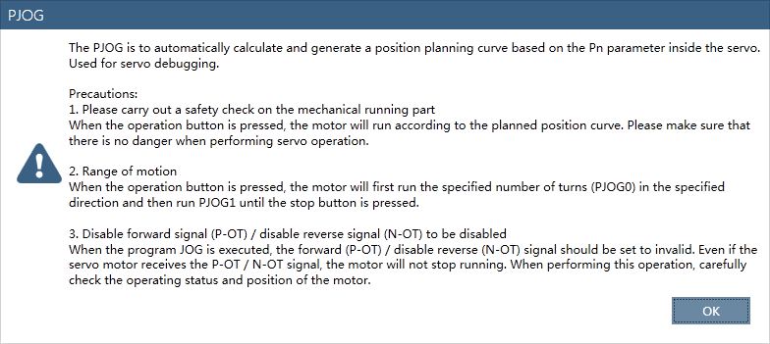
- Popup window 2
If the servo drive has entered to Fnxxx menu by the way of operating panel (4 keys and 5 LEDs), the Program JOG can’t be used in ESVIEW, so the following window will popup. But it is unnecessary in Combo.
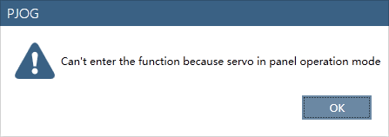
- Popup window 3
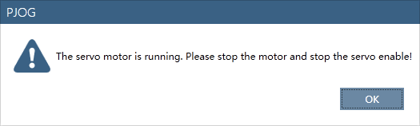
- Main window.
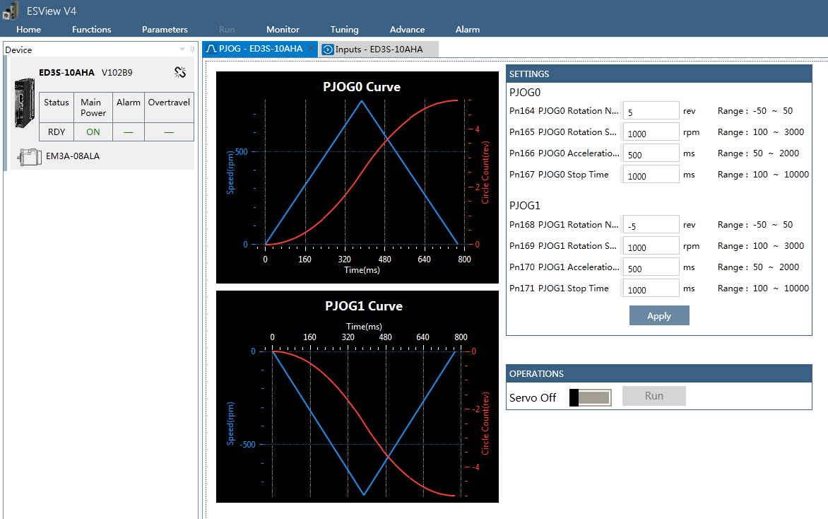
- The flow chart.

相关算法 algorithm
Planned motion trajectory:
The Acc./Dec. time are set by the user, which is different from Parameter Auto-Tuning Tool.

关键技术点及风险点 key technologies and risks
//

Device firmware update

功能描述function description
Device firmware update (DFU) is used to update the DSP or FPGA firmware by USB host or EtherCAT fieldbus.

期望目标function details definition

详细通讯对象 communication objects details
Name | Index | Sub-index | Access | Value
Drive state | 0x30A4 |  | RO | Bit 10: ServoOnState;  1: The motor is power on.  Bit 11~14: SvState;  0: Not ready state without faults;  1: The servo drive is initialized but disabled to run;  2: Ready to run;  3: Motor is running; (power on)  4: Motor is quick stopping;  5: Motor is stopping caused by power off;  6: Fault reaction;  7: Fault state;  8: Not ready state with faults;  9: STO reaction.
DFU_BOOT_VERSION_ADDR | 0x2201 | 0x1 | RO
DFU_STATE_REG1_ADDR | 0x2201 | 0x2 | RO
DFU_STATE_REG2_ADDR | 0x2201 | 0x3 | RO
DFU_BUFFER_ADDR | 0x2201 | 0x4 | WO
DFU_BUFFER_END_ADDR | 0x2201 | 0x43 | WO
DFU_MODE_REG_ADDR | 0x2201 | 0x44 | WO
DFU_BIN_LEN_L_ADDR | 0x2201 | 0x45 | WO
DFU_BIN_LEN_H_ADDR | 0x2201 | 0x46 | WO
DFU_SIZE_CHECK_CMD_ADDR | 0x2201 | 0x47 | WO
DFU_INFO_CHECK_CMD_ADDR | 0x2201 | 0x48 | WO
DFU_ERASE_CMD_ADDR | 0x2201 | 0x49 | WO
DFU_PROG_CMD_ADDR | 0x2201 | 0x50 | WO
DFU_CRC_CHECK_CMD_ADDR | 0x2201 | 0x51 | WO
DFU_COPY_CMD_ADDR | 0x2201 | 0x52 | WO
DFU_FINISH_CMD_ADDR | 0x2201 | 0x53 | WO

通讯流程图 communication flow chart
DSP firmware update function downloads the ESTUN_DSP.bin to DSP’s flash (app code only). There are two steps of this process.
Step 1: app code runs.
DSP communicates with PC or controller via USB, SCI, EtherCAT, receives firmware data and save them to BUFFER. Here, BUFFER is part of the configure flash of FPGA, the flash is divided to 1 Mbytes for BUFFER and another 1Mbytes for FPGA configure data (fpga code).
After the whole file is saved to BUFFER, then decrypt and calculate CRC of the firmware. If the firmware is valid, save a flag to FRAM and reset DSP.
Step 2: boot code runs.
Read the flag from FRAM, then decrypt and calculate CRC of the firmware data. If the firmware is valid, erase app codeand copy decrypted firmware to app code.
Clear the flag in FRAM and reset DSP.
FPGA firmware update process is almost the same, the copy destination is fpga code.
File size check. DSP firmware file size should be 448K bytes constantly, FPGA firmware file size may be variable, but should be less than 1Mbytes because of the BUFFER size limit.
File info check. The app info is a string, e.g. “ED3S_DSP_APP_A_A000_VB.bin”.. Compare the two strings of firmware file and current firmware to avoid wrong firmware updated.

- DSP work flow.

- DFU software work flow:
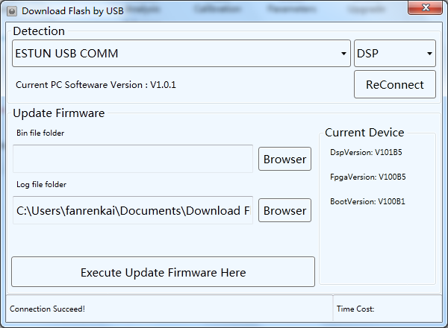
- TwinCATdownload:
If using USB DFU software to update firmware, the servo drive does every step after receiving corresponding command from the software.
If using TwinCAT, the object list in 3.12.3 are all invalid. EtherCAT FoE protocol receives firmware data continuously, and the servo drive jumps to next step automatically.

相关算法 algorithm
- DSP firmware naming rules:
Product series is determined by Vendor ID and Product Code.
BOOT is the bootloader firmware of DSP, can’t be updated via EtherCAT or USB communications.

- FPGA firmware naming rules:
Product series is determined by Vendor ID and Product Code.

- Error codes of FoE:
Error code | Meaning
0x8000 | Not defined
0x8001 | Not found
0x8002 | Access denied
0x8003 | Disk full
0x8004 | Illegal
0x8005 | Packet number wrong
0x8006 | Already exists
0x8007 | No user
0x8008 | Bootstrap only
0x8009 | Not bootstrap
0x800A | No rights
0x800B | Program error

- Failure information:
Probable causes:
- The firmware file is modified illegally.
- The firmware file is not suitable for this type of servo drive.
- Servo drive’s internal error.

关键技术点及风险点 key technologies and risks
//

Sample Scope

功能描述function description
Real time sampling data scope display.

期望目标function details definition
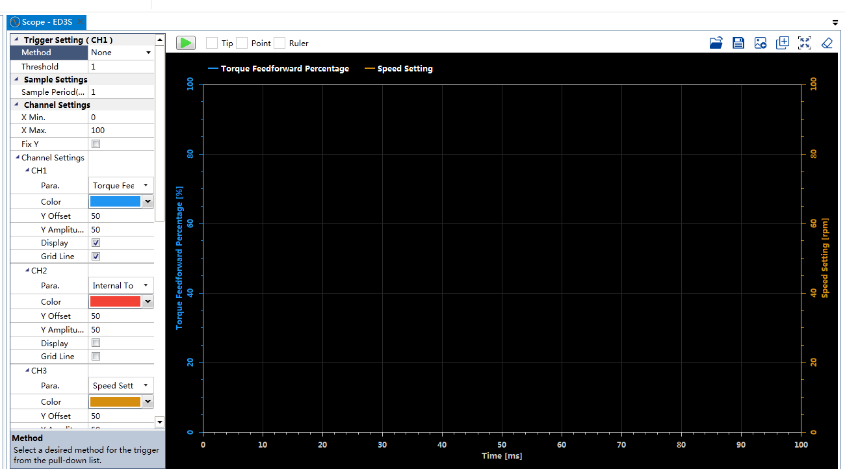

Esview scope function can be referred

详细通讯对象 communication objects details

3.16.3.1 capture setup object

1.1 Trigger Mode, Channel1 Trigger Value, Channel1 Variable Data Type, Sample Time
Setup Object:
Index | Sub Index | Name | Type | Access
0x368C | 0 | Number of entity | UINT8 | RW
 | 1 | Trigger Mode | Uint16 | RW
 | 2 | Channel1Trigger Value 1_L | Uint16 | RW
 | 3 | Channel1Trigger Value 1_H | Uint16 | RW
 | 4 | Channel1Trigger Value 2_L | Uint16 | RW
 | 5 | Channel1Trigger Value 2_H | Uint16 | RW
 | 6 | Channel1 Variable Data Type | Uint16 | RW
 | 7 | Sample Time | Uint16 | RW
 | 8 | SampleChannel1VariableAddr | UINT16 | RW
 | 9 | SampleChannel2VariableAddr | UINT16 | RW
 | 10 | SampleChannel3VariableAddr | Uint16 | RW
 | 11 | SampleChannel4VariableAddr | Uint16 | RW
 | 12 | SampleChannel5VariableAddr | Uint16 | RW
 | 13 | SampleChannel6VariableAddr | Uint16 | RW
 | 14 | SampleChannel7VariableAddr | Uint16 | RW
 | 15 | SampleChannel8VariableAddr | Uint16 | RW

（1）Trigger Mode
There are seven trigger mode which can be set, channel1 variable value is compared with trigger threshold, when the trigger mode condition is matched, sampling will be triggered.

Setting value | Trigger mode | description
0 | No trigger | Click the start button will start sampling
1 | Rising edge | /
2 | Falling edge | /
3 | Change | Not equal to threshold value
4 | Reserved | Reserved for mechanical analysis
5 | Err edge | When alarm is happened
6 | Reserved | Reserved for friction compensation identification
7 | Larger than threshold | /
8 | Less than threshold | /

（2）Channel1 trigger threshold value, channel1 variable data type
Channel1 variable value is compared with trigger threshold, when the trigger mode condition is matched, sampling will be triggered.
The channel1 variable data type should be set to servo as list followed:

Data Type | value
Int16 | 1
Uint16 | 2
Int32 | 3
Uint32 | 4
Int64 | 5
Uint64 | 6

（4）Sample time
Unit is 125us

1.2 Channel, 1, 2,3,4,5,6,7,8 variable address setting
Set sample channel variable address through writing to 0x368C sub-index entity from 8 to 15;
SampleChannel1VariableAddr
SampleChannel2VariableAddr
SampleChannel3VariableAddr
SampleChannel4VariableAddr
SampleChannel5VariableAddr
SampleChannel6VariableAddr
SampleChannel7VariableAddr
SampleChannel8VariableAddr

Variable address:
address | Variable name | Description | Unit | Data Type | Authority
0x0F10 | SPD_FB_RPM_ADDR | Speed feed back | rpm | Int16 | Common
0x0F11 | SPD_CMD_RPM_ADDR | Speed command | rpm | Int16 | Common
0x0F13 | TN_ADDR | Internal torque command percent | %（*Tn） | Int16 | Common
0x0F16 | CURRENT_POSL1_ADDR | Current position low 16bits of 64bits | 1 user position pulse | Int64 | Common
0x0F17 | CURRENT_POSH1_ADDR | Current position medium low 16bits of 64bits | 1 user position pulse | Int64 | Common
0x0F18 | CURRENT_POSL2_ADDR | Current position medium high 16bits of 64bits | 1 user position pulse | Int64 | Common
0x0F19 | CURRENT_POSH2_ADDR | Current position high low 16bits of 64bits | 1 user position pulse | Int64 | Common
0x0F1C | IU_ADDR | Iu | 0.1%(rated current) | Int16 | advanced
0x0F1D | IV_ADDR | Iv | 0.1%(rated current) | Int16 | advanced
0x0F1E | ID_REF_ADDR | Idr | 0.1%(rated current) | Int16 | Common
0x0F1F | ID_ADDR | Id | 0.1%(rated current) | Int16 | Common
0x0F20 | IQ_REF_ADDR | Iqr | 0.1%(rated current) | Int16 | Common
0x0F21 | IQ_ADDR | Iq | 0.1%(rated current) | Int16 | Common
0x0F22 | UD_ADDR | Ud | V | UInt16 | Common
0x0F23 | UQ_ADDR | Uq | V | UInt16 | Common
0x0F2A | EST_SPD_L_ADDR | Observer speed low 16bits | 0.1rpm | Int32 | advanced
0x0F2B | EST_SPD_H_ADDR | Observer speed high 16bits | 0.1rpm | Int32 | advanced
0x0F2C | EST_TORQ_PER_ADDR | Observer torque | 0.1%(rated torque) | Int16 | advanced
0x0F2D | FEEDFORWARD_SPEED_ADDR | Speed feed forward | r/min | Int16 | advanced
0x0F2E | FEEDFORWARD_TORQUE_ADDR | Torque feed forward | 0.1%(rated torque) | UInt16 | advanced
0x0F2F | PGERR_SPEED_ADDR | Position command speed | r/min | Int16 | advanced
0x0F32 | EKL1_ADDR | Position pulse err low 16bits of 64bits | 1 motor encoder pulse | Int64 | Common
0x0F33 | EKH1_ADDR | Position pulse err medium low 16bits of 64bits | 1 motor encoder pulse | Int64 | Common
0x0F34 | EKL2_ADDR | Position pulse err medium high 16bits of 64bits | 1 motor encoder pulse | Int64 | Common
0x0F35 | EKH2_ADDR | Position pulse err high 16bits of 64bits | 1 motor encoder pulse | Int64 | Common
0x0F36 | PG_L1_ADDR | Position command pulse low 16bits of 64bits | 1 user position pulse | Int64 | Common
0x0F37 | PG_H1_ADDR | Position command pulse medium low 16bits of 64bits | 1 user position pulse | Int64 | Common
0x0F38 | PG_L2_ADDR | Position command pulse medium high 16bits of 64bits | 1 user position pulse | Int64 | Common
0x0F39 | PG_H2_ADDR | Position command pulse high 16bits of 64bits | 1 user position pulse | Int64 | Common

Data variables for test address list:
Each of these variables is added 1 per 125us cycle, and each of channels is a triangle graph;
Channel1: from 0xC100 to 0xC11F
Channel2: from 0xC200 to 0xC21F
Channel3: from 0xC300 to 0xC31F
Channel4: from 0xC400 to 0xC31F
Channel5: from 0xC500 to 0xC51F
Channel6: from 0xC600 to 0xC61F
Channel7: from 0xC700 to 0xC71F
Channel8: from 0xC800 to 0xC81F
address | Variable name | Description | Unit | Data Type | Authority
0x0F80 | TEST_CHANNEL1DATA_16BIT_ADDR | Data variable used for Channel 1 testing, | / | UInt16 | Common
0x0F81 | TEST_CHANNEL2DATA_16BIT_ADDR | Data variable used for Channel 2 testing | / | UInt16 | Common
0x0F82 | TEST_CHANNEL3DATA_16BIT_ADDR | Data variable used for Channel 3 testing | / | UInt16 | Common
0x0F83 | TEST_CHANNEL4DATA_16BIT_ADDR | Data variable used for Channel 4 testing | / | UInt16 | Common
0x0F84 | TEST_CHANNEL5DATA_16BIT_ADDR | Data variable used for Channel 5 testing | / | UInt16 | Common
0x0F85 | TEST_CHANNEL6DATA_16BIT_ADDR | Data variable used for Channel 6 testing | / | UInt16 | Common
0x0F86 | TEST_CHANNEL7DATA_16BIT_ADDR | Data variable used for Channel 7 testing | / | UInt16 | Common
0x0F87 | TEST_CHANNEL8DATA_16BIT_ADDR | Data variable used for Channel 8 testing | / | UInt16 | Common

start/stop data capture object
Object:
0x368B
 |  | Type | Access
0x368B | 0: Stop sample  1: Start sample | Uint16 | RW

capture status object
Object
0x3680
Bit0~bit13 | reserved
Bit14:bit15 | 0:not in sampling status  1:sampling  2:sampling is done | RO

capture data object
Data object:
0x3687
Index | Name | Type | length | Access
0x3687 | Capture Data Buffer | domain | 16000bytes(8000words) | RW

Each of channels have 1000 words of data, every data is 16bits word, so eight channels totally have 8000 words of data, and the rank of 8000 data is as follows:
Data0 | Data1 | Data2 | Data3 | Data4 | Data5 | Data6 | Data7
Channel1  Data0 | Channel2  Data0 | Channel3  Data0 | Channel4  Data0 | Channel5 Data0 | Channel6  Data0 | Channel7  Data0 | Channel8 Data0

Data8 | Data9 | Data10 | Data11 | Data12 | Data13 | Data14 | Data15
Channel1  Data1 | Channel2  Data1 | Channel3  Data1 | Channel4  Data1 | Channel5 Data1 | Channel6  Data1 | Channel7  Data1 | Channel8  Data1

Data16 | Data17 | Data18 | Data19 | Data20 | Data21 | Data22 | Data23
Channel1  Data2 | Channel2  Data2 | Channel3  Data2 | Channel4  Data2 | Channel5 Data2 | Channel6  Data2 | Channel7  Data2 | Channel8  Data2

Data24 | Data25 | Data26 | Data27 | Data28 | Data29 | Data30 | Data31
Channel1  Data3 | Channel2  Data3 | Channel3  Data3 | Channel4  Data3 | Channel5 Data3 | Channel6  Data3 | Channel7  Data3 | Channel8  Data3

Data32 | Data33 | Data34 | Data35 | Data36 | Data37 | Data38 | Data39
… | … | … | … | … | … | … | …

通讯流程图 communication flow chart
1.write “setup object 0x368C”（sub index1~15）: trigger mode(1), trigger value(2~5), channel 1 data type(6), sample time(7), each of channels data address(8~15).
2. write “1”to “start/stop object 0x368B”, servo will start sampling and save data.
3. Inquiry “status object 0x3680 bit14~15”, when it is equal to 2, sampling is done.
4. When sampling is done, read “Data object 0x3687”, plot the graph.

相关算法 algorithm
//

关键技术点及风险点 key technologies and risks
//

Software Reset

功能描述function description
Software reset function is used to restart the servo drive via EtherCAT communication. The function will reset DSP, FPGA and ESC chips. If the motor is running, the software reset request will be ignored.

期望目标function details definition

详细通讯对象 communication objects details
Name | Index | Sub-index | Access | Value
Drive state | 0x30A4 |  | RO | Bit 10: ServoState;  1: The motor is power on.  Bit 11~14: SvState;  0: Not ready state without faults;  1: The servo drive is initialized but disabled to run;  2: Ready to run;  3: Motor is running; (power on)  4: Motor is quick stopping;  5: Motor is stopping caused by power off;  6: Fault reaction;  7: Fault state;  8: Not ready state with faults;  9: STO reaction.
Software Reset | 0x2200 |  | RW | Write software reset command:  0x5354 (ASCII “RS”, means software reset request)  Read software reset result:  0x4F4B (ASCII “OK”, means software reset successfully)

通讯流程图 communication flow chart
- Popup window.
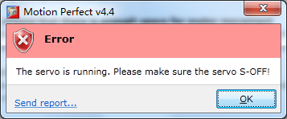
- Flow chart.
- Poll the software reset state if needed.
Read the Software Resetobject, if the result is 0x4F4B, means the servo drive is restart successfully.

相关算法 algorithm
//

关键技术点及风险点 key technologies and risks
//

供参考的ESView描述

Trace功能块

功能描述
连续跟踪采样，实时采集伺服变量上传到ESview并绘制出波形。

期望目标

详细通讯地址
名称 | 通讯地址 | 详细说明 | 单位 | 属性 | 显示范围
启动数据刷新指令 | 0x1280 | 01：启动刷新00：停止刷新 |  | 读写
数据刷新完成标志 | 0x1281 | 01：刷新完成00：刷新未完成 |  | 只读

通讯流程图

相关算法

关键技术点及风险点

负载惯量检测

功能描述
在伺服控制中，负载惯量参数对伺服控制性能尤为重要。由于负载惯量与电机端的负载有关，因此不同设备或应用场合下的惯量是不同的。所以负载惯量检测功能是十分必要的。
这里所谓的负载惯量检测是在离线状态下，伺服内部生成一转速给定曲线，使电机来回运转，再通过电机转速与转矩曲线可计算出系统惯量（电机惯量和负载惯量）。由于电机惯量是已知的，所以测量结果以负载惯量百分比的形式给出。
检测过程中，规划的转速曲线可能会超出负载的移动范围，所以这里有旋转8圈和4圈两种选择。

期望目标

界面打开状态
初始化流程结束后，界面打开。

圈数设定
默认情况下，Pn172为0显示8圈，为1显示4圈。
用户设定时，往Pn172写0即设定8圈，往Pn172写1即设定4圈。Start为1且Finish为0期间（惯量检测期间），不可修改圈数。

负惯比显示
Finish从0变成1（即上升沿），读取惯量检测结果寄存器并显示。

Son/Soff显示
当前Son/Soff显示状态与JMeasSon保持一致。点击Son即发送02至惯量检测命令寄存器；点击Soff即发送03至惯量检测命令寄存器。

开始/停止按钮
开始/停止为同一按钮，Start为1且Finish为0期间（惯量检测期间）显示停止；其它情况显示开始。在Son状态下，点击开始按钮即发送04至惯量检测命令寄存器；运行状态下，按停止按钮即发送03至惯量检测命令寄存器。

保存按钮
点击按钮即发送05至惯量检测命令寄存器。

界面示意图

详细通讯地址
标注：0x0905负载惯量状态检测寄存器bit位含义说明
Bit(s) | Name | Define | Description
8 | Save | 结果保存成功标志 | 1：保存成功
7 | Finish | 检测结束标志 | 1：检测结束（电机停止）
6 | Init | 惯量检测流程初始化标志 | 1：惯量检测流程初始化完成
5 | Start | 启动惯量检测标志 | 0：惯量检测未开始或已经结束（电机停止）  1：惯量检测正在执行（电机运动）
4 | JMeasSon | 惯量检测使能标志 | 1：惯量检测使能
3 | EcatCtrl | EtherCAT总线操作标志 | 1：EtherCAT总线正在操作该功能
2 | UsbBusCtrl | USB总线操作标志（ESVIEW） | 1：USB总线正在操作该功能
1 | MenuCtrl | 按键数码管操作标志 | 1：按键正在操作该功能
0 | JMeas | 惯量检测流程运行标志 | 1：已进入惯量检测功能

名称 | 通讯地址 | 详细说明 | 单位 | 属性 | 显示范围
伺服状态 | 0x0F01 | Bit7使能状态 |  | 只读
惯量检测结果寄存器 | 0x0904 | 负惯比，惯量检测结果 |  | 只读
惯量检测状态寄存器 | 0x0905 | 可查询惯量检测流程的状态 |  | 只读
惯量检测命令寄存器 | 0x102C | 发送惯量检测命令  01：建立连接；  02：使能；  03：去使能；  04：开始检测；  05：保存；  06：退出 |  | 只写

通讯流程图
进入负载惯量检测界面时，操作流程如下：
安全提示框1内容参考现有惯量检测；
安全提示框2：伺服电机正在运行，请先停止电机并停止伺服使能！
退出负载惯量检测时，操作流程如下：
安全提示框3：电机正在运行，是否停止？
安全提示框4：检测结果未保存，是否保存？

相关算法

关键技术点及风险点

摩擦补偿

功能描述
本模块旨在实现系统的摩擦补偿参数的辨识。
摩擦辨识的操作流程与负载惯量检测类似，所操作的对象依然为启动惯量检测。只是运行过程中上位机需要接收并保存电机实际转矩百分比，最终通过ESVIEW中集成的最小二乘法完成摩擦辨识。

期望目标

界面打开状态
初始化流程结束后，界面打开。

负载惯量
如果用户点击负载惯量检测按钮，则调用负载惯量检测界面。即先退出摩擦辨识（按退出流程进行），惯量检测结束后，用户手动退出惯量检测后，自动进入摩擦辨识（按初始化流程进行）。
如果用户直接编辑负惯比文本框，则直接保存至Pn106。

圈数设定
默认情况下，Pn172为0显示8圈，为1显示4圈。
用户设定时，往Pn172写0即设定8圈，往Pn172写1即设定4圈。Start为1且Finish为0期间（惯量检测期间），不可修改圈数。

Son/Soff显示
当前Son/Soff显示状态与JMeasSon保持一致。点击Son即发送02至惯量检测命令寄存器；点击Soff即发送03至惯量检测命令寄存器。

开始/停止按钮
开始/停止为同一按钮，Start为1且Finish为0期间（摩擦辨识期间）显示停止；其它情况显示开始。在Son状态下，点击开始按钮即发送04至惯量检测命令寄存器；运行状态下，按停止按钮即发送03至惯量检测命令寄存器。
点击开始按钮后，上位机操作流程如下：
- 设定采样周期；（写采样时间寄存器，采样周期固定为1）
- 设定触发条件为摩擦辨识触发；（写6至采样数据触发条件寄存器）
- 设定开始采样；（写1至开始采样寄存器）
- 设定开始运行；（写04至惯量检测命令寄存器）
- 查询采样结束标志；（查询伺服驱动器辅助功能状态寄存器，同ESVIEW通用数据采集流程）
- 读取数据；（写地址偏移量至采样数据偏移量寄存器，再读数据缓冲地址1207~121B，同ESVIEW通用数据采集流程）
总的采样点数如下：
圈数 | 开关频率 | 摩擦辨识点数 | 采样周期 | 采样点数
8圈 | 8kHz | 4000 | 1 | 8000
8圈 | 10kHz | 5000 | 1 | 10000
4圈 | 8kHz | 2800 | 1 | 5600
4圈 | 10kHz | 3500 | 1 | 7000
点击停止按钮后，上位机操作流程如下：
- 设定停止运行；（写03至惯量检测命令寄存器）
- 设定停止采样；（写0至开始采样寄存器）

上传数据
上传数据操作流程与绘图、机械分析功能类似。上传数据进度条与ESVIEW风格一致即可。

计算、保存辨识的摩擦量
数据上传结束后，上位机调用最小二乘辨识算法库计算辨识的摩擦量，并显示出来，点击设置按钮保存至Pn参数。

界面示意图

详细通讯地址
名称 | 通讯地址 | 详细说明 | 单位 | 属性 | 显示范围
伺服状态 | 0xF01 | Bit7使能状态 |  | 只读
惯量检测数值 | 0xF04 | 负惯比，惯量检测结果 |  | 只读
惯量检测状态 | 0xF05 | 可查询惯量检测流程的状态 |  | 只读
惯量检测命令寄存器 | 0x102C | 发送惯量检测命令  01：建立连接；  02：使能；  03：去使能；  04：开始检测；  05：保存；  06：退出 |  | 只写

Pn参数：
负惯比 | Pn106 |  |  | 读写
惯量检测时电机旋转圈数 | Pn172 |  |  | 读写
库伦摩擦 | Pn130 |  |  | 读写
粘滞摩擦 | Pn132 |  |  | 读写
开关频率 | Pn940(高级) | 0：10kHz；1：8kHz |  | 只读

通讯流程图
进入摩擦辨识界面时，操作流程如下：
安全提示框1内容参考现有惯量检测；
安全提示框2：伺服电机正在运行，请先停止电机并停止伺服使能！
退出摩擦辨识时，操作流程如下：
安全提示框3：电机正在运行，是否停止？

相关算法
最小二乘法，通过使用者选取的计算起始点N1和计算终止点N2，通过最小二乘法计算出摩擦系数，公式如下，其中a为粘滞摩擦系数，b为库伦摩擦力，x为速度，y为电流百分比。
$$y=ax+b$$
$$b=\frac{(\sum{x_{i}^{2})(\sum{y_{i})-(\sum{x_{i})(\sum{x_{i}y_{i})}}}}}{N(\sum{x_{i}^{2})-N{(\sum{x_{i})}}^{2}}}$$
$$a=\frac{N(\sum{{x_{i}y}_{i})-(\sum{x_{i})(\sum{y_{i})}}}}{N(\sum{x_{i}^{2})-N{(\sum{x_{i})}}^{2}}}$$
程序可参考如下程序：
N=N2-N1; %N即选取的总点数
/*最小二乘法处理*/
for(i=0;i<N;i++)
{
speedall[i]=SPEED[i+N1];
Fall[i]=F[i+N1];
X2[i]=speedall[i]*speedall[i];
XY[i]=speedall[i]*Fall[i];
}
sumx2=sum(X2);//将X2数组的数据求和
sumy=sum(Fall);//将Fall数组的数据求和
sumx=sum(speedall);
sumxy=sum(XY);

Cm_guji=(sumx2*sumy-sumx*sumxy)/(N*sumx2-sumx*sumx);//库伦摩擦力
Bm_guji=(N*sumxy-sumx*sumy)/(N*sumx2-sumx*sumx)*1000;//粘滞摩擦力

关键技术点及风险点

离线参数整定-自动

功能描述
对于一些复杂应用场合，如果用户不熟悉伺服手动参数调整方法，可使用离线参数自动整定对伺服系统进行调谐。
执行该功能时，伺服电机按内部生成的位置曲线运行，运行过程中伺服内部会自动调整增益类参数，并对伺服性能进行评价，最终会找出一组最优的增益参数作为整定结果。
为增强操作界面的友好性，伺服整定过程中，上位机需要读取伺服整定状态的并进行显示；整定结束后，上位机需要读取整定结果并与当前参数进行对比显示，方便用户查看和确认。
考虑到伺服内部生成的曲线可能会超出负载移动范围，这里可以设置POS0和POS1相关Pn参数进行调整。

期望目标

界面打开状态
初始化流程结束后，界面打开。

Pn参数设定
如果用户修改Pn参数，则将修改后的参数写入相应的Pn参数表。如果修改的Pn参数为Pn106或Pn164~Pn171，则参数保存之后再发送07至离线参数整定命令寄存器，查询离线参数整定状态寄存器直到Calc位为1，此时读取1062~1067的数值并显示出来（t1、t2、n）。

负载惯量
如果用户点击负载惯量检测按钮，则自动退出离线参数自整定（按退出流程进行），退出后自动进入负载惯量检测（按初始化流程进行）。惯量检测结束后，用户手动退出惯量检测后，自动进入离线参数自整定（按初始化流程进行）。
如果用户直接编辑负惯比文本框，则直接保存至Pn106。

自动振动抑制
自动振动抑制与自动振动抑制寄存器的值对应，自动振动抑制寄存器可读可写：0为不使能，1为使能。离线参数整定状态寄存器的Start为1时（即开始/停止按钮显示为停止时）不可修改。

Son/Soff显示
当前Son/Soff显示状态与离线参数整定状态寄存器的AutoTuningSon位保持一致。点击Son即发送02至离线参数整定命令寄存器；点击Soff即发送03至离线参数整定命令寄存器。

位置环、速度环进度条
位置环进度条读取当前位置环增益整定值寄存器的值（0~500）；速度环进度条读取当前速度环增益整定值寄存器的值（0~790）。

陷波滤波器、抑振滤波器
陷波滤波器和抑振滤波器的使能状态分别与离线参数整定状态寄存器中的NotchValid和AFilterValid对应。

开始/停止按钮
开始/停止为同一按钮，Start状态为1时显示停止；其它情况显示开始。在Son状态下，点击开始按钮即发送04至离线参数整定命令寄存器；按停止按钮即发送03至离线参数整定命令寄存器。

保存参数界面
整定结束后查询Fail位，如果为1则表示整定失败，应给出提示；如果Fail位为0则进入保存界面。保存参数界面下，分别读取1413~141B和相应的Pn参数值，并显示出来。如果点击保存按钮，则发送05至离线参数整定命令寄存器。查询状态寄存器中的Save位变为1后则保存成功。

界面示意图

详细通讯地址
0x1412离线参数自整定状态寄存器bit位含义说明
Bit(s) | Name | Define | Description
11 | AFilterValid | A型滤波器有效标志 | 1：A型滤波器有效
10 | NotchValid | 陷波滤波器有效标志 | 1：陷波滤波器有效
9 | Fail | 整定失败标志 | 1：自整定失败
8 | Finish | 整定流程结束标志 | 1：自整定结束（电机停止）
7 | Save | 参数保存标志 | 1：参数保存成功
6 | Calc | 路径轨迹规划计算完成标志 | 1：路径轨迹规划计算完成
5 | Start | 启动参数自整定标志 | 0：未开始（电机停止）  1：正在执行（电机运动）
4 | AutoTuningSon | 自整定使能标志 | 1：自整定使能
3 | EcatCtrl | EtherCAT总线操作标志 | 1：EtherCAT总线正在操作该功能
2 | UsbBusCtrl | USB总线操作标志（ESVIEW） | 1：USB总线正在操作该功能
1 | MenuCtrl | 按键数码管操作标志 | 1：按键正在操作该功能
0 | AutoTuning | 自整定流程运行标志 | 1：已进入自整定功能

名称 | 通讯地址 | 详细说明 | 单位 | 属性 | 显示范围
伺服状态 | 0x0F01 | 发送命令  01：建立连接；  02：使能；  03：去使能；  04：开始运行；  05：保存参数；  06：退出；  07：计算（规划曲线参数）； |  | 只读
离线参数自整定命令寄存器 | 0x1410 | 读写自适应陷波器使能标志 |  | 只写
自适应陷波器使能 | 0x1411 | 可查询离线参数自整定的状态 |  | 读写
离线参数自整定状态寄存器 | 0x1412 |  |  | 只读
当前位置环增益整定值 | 0x1413 |  |  | 只读
当前速度环刚性整定值 | 0x1414 |  |  | 只读
当前速度环比例整定值 | 0x1415 |  |  | 只读
当前速度环积分整定值 | 0x1416 |  |  | 只读
当前转矩给定滤波时间常数整定值 | 0x1417 |  |  | 只读
当前抑振滤波器频率整定值 | 0x1418 |  |  | 只读
当前陷波滤波器1频率整定值 | 0x1419 |  |  | 只读
当前陷波滤波器2频率整定值 | 0x141A |  |  | 只读
当前陷波滤波器3频率整定值 | 0x141B |  |  | 只读
PJOG0加速时间 | 0x1062 |  |  | 只读
PJOG0匀速时间 | 0x1063 |  |  | 只读
PJOG0最高转速 | 0x1064 |  |  | 只读
PJOG1加速时间 | 0x1065 |  |  | 只读
PJOG1匀速时间 | 0x1066 |  |  | 只读
PJOG1最高转速 | 0x1067 |  |  | 只读

通讯流程图
进入离线参数自整定界面时，操作流程如下：
安全提示框1：参考ESVIEW3.0中JOG的安全提示界面，内容作部分修改；
功能介绍：
离线参数整定（自动整定）功能由伺服内部给定位置指令，运行过程中自动调整增益参数使伺服系统达到较优的性能。该功能对转矩控制模式无效。
注意事项：
1. 请对机械运转部分进行安全检查.
当操作按钮被按下后, 电机将按照规划位置曲线运行, 请确定在执行伺服操作时不会发生危险.
2. 运动范围.
当操作按钮被按下后,电机将先向指定方向运行指定圈数（PJOG0）再运行PJOG1, 持续运行直至整定流程结束或按下停止按钮.
3.紧急情况下，可以按下停止按钮停止电机.
安全提示框2：伺服电机正在运行，请先停止电机并停止伺服使能！
退出离线参数自整定时，操作流程如下：
安全提示框3：电机正在运行，是否停止？

相关算法

关键技术点及风险点

免调整

功能描述
免调整是一种在线的参数调谐模式。SON状态下，该模式会根据伺服运行情况进行实时、在线地调整，使用户不需要设置过多的参数（不需要设置任何增益类参数）即可获得令人满意的性能。

期望目标

自动振动抑制
自动振动抑制与自动振动抑制寄存器的值对应，自动振动抑制寄存器可读可写：0为不使能，1为使能。

高级设置
点击高级设置后需输入密码才可进入。刚性等级、DOB带宽、DOB内部负惯比分别对应Pn101、Pn161和Pn160的参数。

界面示意图

详细通讯地址
名称 | 通讯地址 | 详细说明 | 单位 | 属性 | 显示范围
参数调谐模式  寄存器 | 0x141D | 发送命令  01：免调整；  02：单参数调谐mode1；  03：单参数调谐mode2；  04：手动调谐mode1；  05：手动调谐mode2； |  | 读写
自动振动抑制寄存器 | 0x1411 | 读写自适应陷波器使能标志 |  | 读写

通讯流程图
安全提示框1：
功能介绍：
免调整功能是指不需要用户调整增益参数即可使伺服系统满足基本的动态响应和负载适应性能。该功能对转矩控制模式无效。
注意事项：
1.使用前应做好参数备份.
免调整执行过程中伺服会自动修改增益参数，被修改的参数将不可恢复，所以建议使用前进行参数备份.
2. 确保在紧急情况下，控制器能停止向伺服发送位置指令或速度指令，并能向伺服发送停止使能命令。
安全提示框2：离线参数整定—自动整定正在运行，请先退出该流程；
安全提示框3：当前模式不是免调整模式，重新上电可使免调整模式生效，有确定和取消两个按钮；
直接退出；

相关算法

关键技术点及风险点

单参数调谐Mode1

功能描述
在一些简单应用场合或刚性连接应用场合，可仅仅设定刚性参数即可使伺服性能达到令人满意的效果。该功能为在线参数调整，运行时，伺服内部会根据设定的刚性参数自动计算出一系列增益参数。该功能可大大简化伺服调谐难度。Mode1下，负载惯量百分比使用伺服内部相关功能模块实时计算的结果。该功能可用于一些负载惯量比变化的场合。

期望目标

自动振动抑制
自动振动抑制与自动振动抑制寄存器的值对应，自动振动抑制寄存器可读可写：0为不使能，1为使能。

刚性等级设置
刚性等级设置可以直接在文本框中输入，也可以直接拖动进度条，点击“设置”时将数值写入Pn101。Pn101最大值和最小值从Pn参数表中获取。

标准型和稳定型设置
标准型和稳定型通过标准型/稳定型寄存器来设定：0为标准型；1为稳定型。

界面示意图

详细通讯地址
名称 | 通讯地址 | 详细说明 | 单位 | 属性 | 显示范围
参数调谐模式  寄存器 | 0x141D | 发送命令  01：免调整；  02：单参数调谐mode1；  03：单参数调谐mode2；  04：手动调谐mode1；  05：手动调谐mode2； |  | 读写
自适应陷波器使能 | 0x1411 | 读写自适应陷波器使能标志 |  | 读写
标准型/稳定型选择 | 0x141E |  |  | 读写

通讯流程图
安全提示框1：
功能介绍：
单参数调谐功能是指只需要调整一个参数（刚性等级）即可使伺服系统达到较优的性能。该功能对转矩控制模式无效。Mode1使用在线辨识负惯比，Mode2使用参数设定负惯比。
注意事项：
1.使用前应做好参数备份.
单参数调谐过程中，调整的参数会实时保存至伺服控制器，被修改的参数将不可恢复，所以建议使用前进行参数备份.
2. 确保在紧急情况下，控制器能停止向伺服发送位置指令或速度指令，并能向伺服发送停止使能命令。
安全提示框2：离线参数整定—自动整定正在运行，请先退出该流程；
安全提示框3：当前模式不是单参数调谐模式，重新上电可使单参数调谐模式生效，有确定和取消两个按钮；
直接退出；

相关算法

关键技术点及风险点

单参数调谐Mode2

功能描述
基本功能同单参数调谐Mode1，差别在于Mode2下，负载惯量百分比为Pn106读取值。
该功能可用于一些负载惯量比固定的场合。为方便用户调整负载惯量百分比参数，界面中包含负惯比设定部分。

期望目标

自动振动抑制
自动振动抑制与自动振动抑制寄存器的值对应，自动振动抑制寄存器可读可写：0为不使能，1为使能。

刚性等级设置
刚性等级设置可以直接在文本框中输入，也可以直接拖动进度条，点击“设置”时将数值写入Pn101。Pn101最大值和最小值从Pn参数表中获取。

标准型和稳定型设置
标准型和稳定型通过地址标准型/稳定型寄存器来设定：0为标准型；1为稳定型。

界面示意图

详细通讯地址
名称 | 通讯地址 | 详细说明 | 单位 | 属性 | 显示范围
参数调谐模式  寄存器 | 0x141D | 发送命令  01：免调整；  02：单参数调谐mode1；  03：单参数调谐mode2；  04：手动调谐mode1；  05：手动调谐mode2； |  | 读写
自适应陷波器使能 | 0x1411 | 读写自适应陷波器使能标志 |  | 读写
标准型/稳定型选择 | 0x141E |  |  | 读写

通讯流程图
安全提示框1：
功能介绍：
单参数调谐功能是指只需要调整一个参数（刚性等级）即可使伺服系统达到较优的性能。该功能对转矩控制模式无效。Mode1使用在线辨识负惯比，Mode2使用参数设定负惯比。
注意事项：
1.使用前应做好参数备份.
单参数调谐过程中，调整的参数会实时保存至伺服控制器，被修改的参数将不可恢复，所以建议使用前进行参数备份.
2. 确保在紧急情况下，控制器能停止向伺服发送位置指令或速度指令，并能向伺服发送停止使能命令。
安全提示框2：离线参数整定—自动整定正在运行，请先退出该流程；
安全提示框3：当前模式不是单参数调谐模式，重新上电可使单参数调谐模式生效，有确定和取消两个按钮；
直接退出；

相关算法

关键技术点及风险点

手动调谐Mode1

功能描述
这里的手动调谐是指在线运行，即用户设备边运行边手动调整参数，差别在于位置指令或转速指令为上位机给定，手动调谐的方法与离线手动参数整定一致。Mode1下，负载惯量百分比使用伺服内部相关功能模块实时计算的结果。该功能可用于一些负载惯量比变化的场合。

期望目标

Pn参数设定和显示
初始化时，Pn参数显示值从Pn参数表读取。用户修改后自动保存Pn参数至伺服，并同步显示修改后的值。

自动振动抑制
自动振动抑制与自动振动抑制寄存器的值对应，自动振动抑制寄存器可读可写：0为不使能，1为使能。自动振动抑制勾选后，Pn181、Pn184、Pn187、Pn173不显示；否则显示这些参数。

增益切换和增益切换条件下拉框
初始化时，增益切换状态与增益切换使能寄存器的值对应：0为不使能，增益切换条件下拉框不显示或显示为灰色；1~8为使能，增益切换条件下拉框显示对应的数值，每个数值意义如下表。
0 | 固定到第一组增益
1 | 固定到第二组增益
2 | 转矩指令百分比
3 | 偏差计数器
4 | 给定加速度
5 | 给定速度
6 | 有位置指令输入
7 | 实际速度
8 | 位置指令和速度反馈
增益切换使能寄存器可读可写，用户使能增益切换或修改增益切换条件时，应将对应的数值写入增益切换使能寄存器。

振动抑制使能前后

增益切换——条件1

增益切换——条件2~7

增益切换——条件8

详细通讯地址
名称 | 通讯地址 | 详细说明 | 单位 | 属性 | 显示范围
参数调谐模式  寄存器 | 0x141D | 发送命令  01：免调整；  02：单参数调谐mode1；  03：单参数调谐mode2；  04：手动调谐mode1；  05：手动调谐mode2； |  | 读写
自适应陷波器使能 | 0x1411 | 读写自适应陷波器使能标志 |  | 读写
增益切换使能 | 0x141C |  |  | 读写

通讯流程图
安全提示框1：
功能介绍：
手动参数调谐功能是指手动调整伺服增益参数使伺服系统达到较优的性能。该功能对转矩控制模式无效。Mode1使用在线辨识负惯比，Mode2使用参数设定负惯比。
注意事项：
1.使用前应做好参数备份.
手动参数调谐过程中，调整的参数会实时保存至伺服控制器，被修改的参数将不可恢复，所以建议使用前进行参数备份.
2. 确保在紧急情况下，控制器能停止向伺服发送位置指令或速度指令，并能向伺服发送停止使能命令。

安全提示框2：离线参数整定—自动整定正在运行，请先退出该流程；
安全提示框3：当前模式不是手动调谐模式，重新上电可使手动调谐模式生效，有确定和取消两个按钮；
直接退出；

相关算法

关键技术点及风险点

手动调谐Mode2

功能描述
基本功能同手动调谐Mode1，差别在于Mode2下，负载惯量百分比为Pn106读取值。该功能可用于一些负载惯量比固定的场合。为方便用户调整负载惯量百分比参数，界面中包含负惯比设定部分。

该功能可用于一些负载惯量比固定的场合。期望目标
同手动调谐Mode1。仅增加负惯比设定部分。
如果用户点击进入负载惯量检测，则按照负载惯量检测流程进行初始化、操作，退出时自动返回本界面。

界面示意图

详细通讯地址
名称 | 通讯地址 | 详细说明 | 单位 | 属性 | 显示范围
参数调谐模式  寄存器 | 0x141D | 发送命令  01：免调整；  02：单参数调谐mode1；  03：单参数调谐mode2；  04：手动调谐mode1；  05：手动调谐mode2； |  | 读写
自适应陷波器使能 | 0x1411 | 读写自适应陷波器使能标志 |  | 读写
增益切换使能 | 0x141C |  |  | 读写

通讯流程图
安全提示框1：
功能介绍：
手动参数调谐功能是指手动调整伺服增益参数使伺服系统达到较优的性能。该功能对转矩控制模式无效。Mode1使用在线辨识负惯比，Mode2使用参数设定负惯比。
注意事项：
1.使用前应做好参数备份.
手动参数调谐过程中，调整的参数会实时保存至伺服控制器，被修改的参数将不可恢复，所以建议使用前进行参数备份.
2. 确保在紧急情况下，控制器能停止向伺服发送位置指令或速度指令，并能向伺服发送停止使能命令。
安全提示框2：离线参数整定—自动整定正在运行，请先退出该流程；
安全提示框3：当前模式不是手动调谐模式，重新上电可使手动调谐模式生效，有确定和取消两个按钮；
直接退出；

相关算法

关键技术点及风险点

程序位置JOG

功能描述
程序位置JOG即伺服内部生成一位置规划曲线，用于伺服试运行或离线参数调谐。与JOG的差别在于：JOG是速度控制模式、程序位置JOG为位置控制模式。
考虑到伺服内部生成的曲线可能会超出负载移动范围，这里可以设置PJOG0和PJOG1相关Pn参数进行调整。

期望目标

界面打开状态
初始化流程结束后，界面打开。

Pn参数设定
如果用户修改Pn参数，则将修改后的参数写入相应的Pn参数表，发送07至程序位置JOG命令寄存器，查询程序位置JOG状态寄存器直到Calc位为1，此时读取0x1062、0x1063、0x1064、1065、1066、1067的数值并显示出来（t1、t2、n），停止时间显示Pn设定值。

Son/Soff显示
当前Son/Soff显示状态与PJOGSon保持一致。点击Son即发送02至程序位置JOG命令寄存器；点击Soff即发送03至程序位置JOG命令寄存器。

开始/停止按钮
开始/停止为同一按钮，Start状态为1时显示停止；其它情况显示开始。在Son状态下，点击开始按钮即发送04至程序位置JOG命令寄存器；按停止按钮即发送03至程序位置JOG命令寄存器。

界面示意图

详细通讯地址
名称 | 通讯地址 | 详细说明 | 单位 | 属性
伺服状态 | 0x0F01 | bit7代表伺服使能状态 |  | 只读
程序位置JOG状态寄存器 | 0x1061 | 可查询程序位置JOG的状态 |  | 只读
PJOG0加速时间 | 0x1062 | 读取规划曲线0的加速时间t1，单位ms |  | 只读
PJOG0匀速时间 | 0x1063 | 读取规划曲线0的匀速时间t2，单位ms |  | 只读
PJOG0最高转速 | 0x1064 | 读取规划曲线0的最高转速n，单位rpm |  | 只读
PJOG1加速时间 | 0x1065 | 读取规划曲线1的加速时间t1，单位ms |  | 只读
PJOG1匀速时间 | 0x1066 | 读取规划曲线1的匀速时间t2，单位ms |  | 只读
PJOG1最高转速 | 0x1067 | 读取规划曲线1的最高转速n，单位rpm |  | 只读
程序位置JOG命令寄存器 | 0x1060 | 发送程序位置JOG命令  01：建立连接；  02：使能；  03：去使能；  04：开始运行；  06：退出；  07：计算（规划曲线参数）； |  | 只写
PJOG0旋转圈数 | Pn164 | 读写Pn参数表 |  | 读写
PJOG0旋转速度 | Pn165 | 读写Pn参数表 |  | 读写
PJOG0加减速时间 | Pn166 | 读写Pn参数表 |  | 读写
PJOG0停止时间 | Pn167 | 读写Pn参数表 |  | 读写
PJOG1旋转圈数 | Pn168 | 读写Pn参数表 |  | 读写
PJOG1旋转速度 | Pn169 | 读写Pn参数表 |  | 读写
PJOG1加减速时间 | Pn170 | 读写Pn参数表 |  | 读写
PJOG1停止时间 | Pn171 | 读写Pn参数表 |  | 读写

通讯流程图
进入程序位置JOG界面时，操作流程如下：
安全提示框1：参考ESVIEW3.0中JOG的安全提示界面，内容作部分修改；
1. 请对机械运转部分进行安全检查.
当操作按钮被按下后, 电机将按照规划位置曲线运行, 请确定在执行伺服操作时不会发生危险.
2. 运动范围.
当操作按钮被按下后,电机将先向指定方向运行指定圈数（PJOG0）再运行PJOG1,持续运行直至按下停止按钮.
安全提示框2：伺服电机正在运行，请先停止电机并停止伺服使能！
退出程序位置JOG时，操作流程如下：
安全提示框3：电机正在运行，是否停止？

相关算法

关键技术点及风险点

电机动力线接线离线诊断功能块

功能描述
预期在Esview的向导设置中插入一个页面，实现电机动力线接线离线诊断功能；
向导设置到达这一页面以后，允许用户选择跳过该诊断步骤；
用户通过点击“开始诊断”按钮后，弹窗“请确认电机动力线和编码器线是否已接好？”，如果用户点击”否”，则无动作；如果用户点击“是”，Esview诊断伺服驱动器是否处于使能状态，如果处于使能状态，弹窗提示”驱动器处于使能状态，禁止启动此项诊断”，如果驱动器处于未使能状态，则触发驱动器进行电机动力线的离线诊断功能；
离线诊断开始后，Esview实时读取电机转子的角度位置信息，并以时钟界面方式，动态显示当前电机转子位置；离线诊断开始后，Esview连续读取驱动器中的诊断状态标志，检测到诊断结束，根据驱动器提供的诊断结果，弹窗或文本打印提示“未检测到电机动力线接线异常”或“请检查电机动力线接线”；

期望目标

详细通讯地址

名称 | 通讯地址 | 详细说明 | 单位 | 属性 | 显示范围
诊断开始标志 | 0x1600 | 0：不进行诊断；  1：开始诊断 |  | 读写
电机旋转角度（32位） | 0x1601  0x1602 | 电机旋转角度 | 度 | 读写 | 0~360
诊断状态 | 0x1603 | Hex0:  - 诊断未结束；  - 诊断顺利结束；  Hex1：  - Hex1无接线错误；  - 有接线错误； |  | 读写

通讯流程图

相关算法

关键技术点及风险点

Esview电机参数导入/读取功能

功能描述
未来从某个时间点开始公司出厂的电机编码器中都会保存电机参数，当新一代伺服上电后会首先从电机编码器中获取电机相关参数才能运行系统；
用户现场有可能存在个别电机，是从该时间点之前出厂，电机编码器中没有保存电机参数，此时新一代伺服无法获取参数，导致系统不能运行；
针对以上情景，需要设计Esview相关功能，通过该功能能够把电机参数导入到伺服的Pn参数中进行保存，伺服上电后从Pn参数中获取电机参数，使得系统仍然能够正常运行。
电机参数读取功能，可供用户确认电机参数是否正确。

期望目标
1电机参数导入功能
1、用户连接Esview软件，输入高级用户密码后，选择电机参数导入功能；
2、在该功能下，Esview自动加载电机参数数据库，显示电机参数文件列表；
3、用户选择通过文件列表选择电机后，Esview界面上显示出电机基本参数（部分参数，如额定电流、额定转矩、额定转速、最高转速等不需要保密的参数，非所有参数），供用户校对；
4、系统解析电机参数，对应到伺服相应Pn参数；
5、用户通过导入操作将电机参数保存到伺服Pn参数中；
6、用户设置伺服Pn参数：电机参数选择方式，选择从Pn参数获取参数；
7、系统上电后不再从编码器中获取电机参数，而是从Pn参数中获取。

2电机参数读取功能
1、系统上电；
2、用户连接ESVIEW软件，输入高级用户密码后，选择电机参数读取功能；
3、在该功能下，Esview读取并显示当前驱动器中电机基本参数（部分参数，非所有参数），用户可进行校对；
4、驱动器中设计相应的MODBUS地址，对应电机基本参数。

3 电机参数关系表
4配套功能
1、Esview团队外开发独立的“电机参数excel到XML文件转换软件”。
该软件将归档的电机参数Excel文件生成XML文件，后期维护时期产品部使用XML文件及特定软件（该软件是通用软件）生成Esview需要的数据库文件（类似setup补丁文件）。
2、从excel文件到XML文件的生成由文档管理者操作。

详细通讯地址
名称 | 通讯地址 | 详细说明 | 单位 | 属性 | 显示范围
 | 0x1640 |  |  | 读写
 | 0x1640 |  |  | 读写

通讯流程图

相关算法

关键技术点及风险点
1、关于数据库文件的维护
由产品部对数据库文件维护，当出现新电机时，产品部使用该电机参数XML文件及特定软件生成Esview需要的数据库文件，提供给技术服务人员；
2、关于用户告知
技术服务人员将电机参数导入驱动器后，设置选择从Pn途径获取电机参数后，需告知客户，该台驱动器不能更换电机使用，若更换电机使用，需要通过我司技术服务人员操作（更换电机时，需将Pn参数设置为从电机编码器获取）；
3、关于Esview增加特殊提示
Esview连接上驱动器后，读取伺服Pn895.0，若判断伺服设置为“从Pn获取电机参数”，则提示用户“本驱动器进行过特殊参数设置，请对电机确认，保证匹配”；
Pn895.0参数含义如下：
0：从编码器E2ROM获取电机参数
1：从Pn获取电机参数
4、关于伺服不匹配报警
当用户选择“从Pn获取电机参数”时，伺服软件通过1区中的电机型号对电机进行检查，若功率不匹配则进行电机不匹配报警（同一类型下不同功率电机可以判断，但不能区分电机类型如EMG和Surpass，因此不能覆盖所有情况）。

配置EtherCAT回零方式

功能描述
用户需按照实际的应用，进入设定回零界面操作相关的参数。
回零方式的选择需设定伺服参数Pn705。

期望目标
1. 正确连接设备后，双击“设备栏”中的“控制设置>回零”，可进入“回零”窗口。
2. 根据需要，设定“Pn705回零方式选择”：
3. 单击“下一步”。
4. 单击“确定”，ESView V4将自动执行写入操作。
单击“取消”，ESView V4不执行写入操作，并关闭“回零”窗口。

详细通讯地址
1、相关的Pn参数

Pn参数 | Esview写入数值 | 回零模式详细说明 | 总线回零模式 | 属性 | 地址
Pn720 | 0x01 | 离开负限位后，标记第一个C脉冲回零 | 回零模式1 | 读写
 | 0x02 | 离开正限位后，标记第一个C脉冲回零 | 回零模式2 | 读写
 | 0x03~0x04 | 使用C脉冲和正向参考点开关 | 回零模式3/4 | 读写
 | 0x03 | 离开正参考点后，第一个C脉冲标记回零 | 回零模式3 | 读写
 | 0x04 | 接触正参考点后，第一个C脉冲标记回零 | 回零模式4 | 读写
 | 0x05~0x06 | 使用C脉冲和负向参考点开关 | 回零模式5/6 | 读写
 | 0x05 | 离开负参考点后，第一个C脉冲标记回零 | 回零模式5 | 读写
 | 0x06 | 接触负参考点后，第一个C脉冲标记回零 | 回零模式6 | 读写
 | 0x07~0x0A | 使用C脉冲、参考点开关和正限位开关 | 回零模式7~10 | 读写
 | 0x07 | 离开回零开关的下降沿后，第一个C脉冲标记回零，初始正向运动 | 回零模式7 | 读写
 | 0x08 | 接触回零开关的下降沿后，第一个C脉冲标记回零，初始正向运动 | 回零模式8 | 读写
 | 0x09 | 接触回零开关的上升沿后，第一个C脉冲标记回零，初始正向运动 | 回零模式9 | 读写
 | 0x0A | 离开回零开关的上升沿后，第一个C脉冲标记回零，初始正向运动 | 回零模式10 | 读写
 | 0x0B~0x0E | 使用C脉冲、参考点开关和负限位开关 | 回零模式11-14 | 读写
 | 0x0B | 离开回零开关的下降沿后，第一个C脉冲标记回零，初始负向运动 | 回零模式11 | 读写
 | 0x0C | 接触回零开关的上升沿后，第一个C脉冲标记回零，初始负向运动 | 回零模式12 | 读写
 | 0x0D | 接触回零开关的上升沿后，第一个C脉冲标记回零，初始负向运动 | 回零模式13 | 读写
 | 0x0E | 离开回零开关的下降沿后，第一个C脉冲标记回零，初始负向运动 | 回零模式14 | 读写
 | 0x11 | 负限位开关下降沿 | 回零模式17 | 读写
 | 0x12 | 正限位开关下降沿 | 回零模式18 | 读写
 | 0x13~0x14 | 参考开关类似方法3、4 | 回零模式19~20 | 读写
 | 0x13 | 回零开关下降沿回零（正向回零开关） | 回零模式19 | 读写
 | 0x14 | 回零开关上升沿回零  （正向回零开关） | 回零模式20 | 读写
 | 0x15~0x16 | 参考开关类似方法5、6 | 回零模式21~22 | 读写
 | 0x15 | 回零开关下降沿回零  （负向回零开关） |  | 读写
 | 0x16 | 回零开关下降沿回零  （负向回零开关） |  | 读写
 | 0x17~0x1A | 与方法7~10相似 | 回零模式23~26 | 读写
 |  | 回零开关负边下降沿回零，初始正向运动 | 回零模式23 | 读写
 |  | 回零开关负边上降沿回零，初始正向运动 | 回零模式24 | 读写
 |  | 回零开关正边上降沿回零，初始正向运动 | 回零模式25 | 读写
 |  | 回零开关正边下降沿回零，初始正向运动 | 回零模式26 | 读写
 | 0x1B~0x1E | 与方法11~14相似 | 回零模式  27~30 | 读写
 | 0x1B | 回零开关正边下降沿回零，初始负向运动 | 回零模式27 | 读写
 | 0x1C | 回零开关正边上降沿回零，初始负向运动 | 回零模式  28 | 读写
 | 0x1D | 回零开关负边上降沿回零，初始负向运动 | 回零模式  29 | 读写
 | 0x1E | 回零开关负边下降沿回零，初始负向运动 | 回零模式  30 | 读写
 | 0x23 | 当前位置为零点 | 回零模式35 | 读写
Pn724 | Homeoffset | 回零偏移量 | Int32
Pn721 | Switch_speed | 参考点速度 | Uint32
Pn722 | Zero_speed | 回零速度 | Uint32
Pn723 | Homing_Acceleration | 回零加速度 | Uint32

通讯流程图

相关算法

关键技术点及风险点

编码器设定以及读取（第二编码器设定）

功能描述
增加编码器设定界面面（可设定第二编码器）可显示位置信息，并有图形化展示。
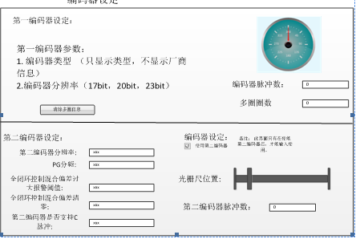
0x0F3B
0x0F3B
0x0F3C
0x0F3A
0x0036
0x0035

期望目标
1. 正确连接设备后，双击“设备栏”中的“编码器>编码器设定”，可进入“编码器设定”窗口，如下图所示。
2. 按照实际的应用，设定“编码器配置”。
3. 根据需要，可执行“编码器操作”。包括清除编码器报警（0x1040）以及清除编码器多圈信息（0x1041）。
4. 单击“确定”，ESView将自动执行写入操作。
5.右侧显示编码器位置信息
单击“取消”，ESView不执行写入操作，并关闭“编码器设定”窗口

详细通讯地址
第一编码器部分
Pn参数 | Esview获取值 | 详细说明 | 单位 | 属性 | 通讯地址
 |  | 编码器类型（0-增量 1-绝对） |  | 只读 | 0x0035
 |  | 编码器分辨率（十六进制）  （17 20 23） |  | 只读 | 0x0036
 |  | 多圈圈数（多圈） |  | 只读 | 0x0F3A
 |  | 编码器脉冲数（单圈） |  | 只读 | 0x0F3B  0x0F3C

第二编码器部分
Pn参数 | Esview写入数值 | 详细说明 | 单位 | 属性 | 通讯地址
Pn210 | 0~15 | 第二编码器的设置1  //bit0: 0-不使用外部第二编码器；1-使用第二编码器  //bit1: 0-使用第一编码器进行分频输出；1-使用外部第二编码器进行分频输出  //bit2: PG分频脉冲相位选择：0-维持现有状态；1-分频脉冲相位取反  //bit3: 第二编码器脉冲计数方向。[0]不变 [1]取反 |  | 读写 | 0x0394  0x0395
Pn211 |  | 第二编码器的设置2  //bit0: 0-第二编码器不支持C脉冲；1-第二编码器支持C脉冲  //bit1: 保留  //bit2: 保留  //bit3: 保留 |  | 读写 | 0x0396  0x0397
Pn212 | 1~1048576 | 外部第二编码器分辨率（电机旋转一圈对应外部编码器输出的AB脉冲沿个数） |  | 读写 | 0x0398  0x0399
Pn213 | 0-134217728 | 全闭环控制混合偏差(电机-负载位置间偏差)过大报警阀值 |  |  | 0x039A  0x039B
Pn214 | 0-100 | 全闭环旋转一圈混合偏差(电机-负载位置间偏差)清除的百分比 |  |  | 0x039C  0x039D
Pn200 | 16~16384 | Pg分频 |  |  | 0x0392  0x0393
 |  | 第二编码器脉冲数（16位） |  | 只读 | 0x0F3B

通讯流程图

相关算法

关键技术点及风险点
第二编码器可单独配置和显示光栅尺的位置

参数表设计

功能描述
上传下载Pn参数功能

期望目标
1、Pn参数的管理
1、伺服内部实际存在三种参数，普通用户参数，高级用户参数，总是隐藏的参数；
总是隐藏的参数有些是用于将来扩展增加参数使用的，有些是用于特殊功能的（如模拟量校正值、伺服日志保存值等）；
2、Esview的Pn参数管理只需管理两种参数，普通用户参数、高级用户参数；
3、总是隐藏的参数让相应的功能去管理，若某些特殊功能想把参数开放出来，则伺服内部将属性从总是隐藏修改为高级用户，然后修改相应的数据库，则Esview中就可以显示。
2、Pn参数的规划
1、具体详见规划的Pn参数表。

详细通讯地址

通讯流程图

相关算法

关键技术点及风险点

示波器参数规格设计

功能描述
采样伺服参数功能

期望目标

详细通讯地址
注：高亮为高级参数灰体为去掉的参数
通信地址 | 变量名称 | 详细描述 | 单位 | 参数类型
0x0F10 | SPD_FB_RPM_ADDR | 速度反馈 | rpm | 普通
0x0F11 | SPD_CMD_RPM_ADDR | 速度给定 | rpm | 普通
0x0F12 | TCMD_ADDR | 输入扭矩指令百分比 | %（*Tn）
0x0F13 | TN_ADDR | 内部扭矩指令百分比 | %（*Tn） | 普通
0x0F16 | CURRENT_POSL1_ADDR | 当前位置低位1 |  | 普通
0x0F17 | CURRENT_POSH1_ADDR | 当前位置中低位1 |  | 普通
0x0F18 | CURRENT_POSL2_ADDR | 当前位置中高位2 |  | 普通
0x0F19 | CURRENT_POSH2_ADDR | 当前位置高位2 |  | 普通
0x0F1C | IU_ADDR | Iu | 1/1000（额定电流） | 高级
0x0F1D | IV_ADDR | Iv | 1/1000（额定电流） | 高级
0x0F1E | ID_REF_ADDR | Idr | 1/1000额定电流 | 普通
0x0F1F | ID_ADDR | Id | 1/1000额定电流 | 普通
0x0F20 | IQ_REF_ADDR | Iqr | 1/1000额定电流 | 普通
0x0F21 | IQ_ADDR | Iq | 1/1000额定电流 | 普通
0x0F22 | UD_ADDR | Ud | V | 普通
0x0F23 | UQ_ADDR | Uq | V | 普通
0x0F24 | SPD_FB_L_ADDR | 速度给定低16位 | 0.1rpm | 高级
0x0F25 | SPD_FB_H_ADDR | 速度给定高16位 | 0.1rpm | 高级
0x0F26 | VCMD_L_ADDR | 速度反馈低16位 | 0.1rpm | 高级
0x0F27 | VCMD_H_ADDR | 速度反馈高16位 | 0.1rpm | 高级
0x0F29 | TORQ_FB_ADDR | 反馈转矩百分比 | %
0x0F2A | EST_SPD_L_ADDR | 观测速度低16位 | 0.1rpm | 高级
0x0F2B | EST_SPD_H_ADDR | 观测速度高16位 | 0.1rpm | 高级
0x0F2C | EST_TORQ_PER_ADDR | 观测转矩千分比 | 0.1% | 高级
0x0F2D | FEEDFORWARD_SPEED_ADDR | 速度前馈 | r/min | 高级
0x0F2E | FEEDFORWARD_TORQUE_ADDR | 转矩前馈百分比 | 0.1% | 高级
0x0F2F | PGERR_SPEED_ADDR | 位置指令速度 | r/min | 高级
0x0F32 | EKL1_ADDR | 偏差脉冲计数低位1 |  | 普通
0x0F33 | EKH1_ADDR | 偏差脉冲计数中低位2 |  | 普通
0x0F34 | EKL2_ADDR | 偏差脉冲计数中高位3 |  | 普通
0x0F35 | EKH2_ADDR | 偏差脉冲计数高位4 |  | 普通
0x0F36 | PG_L1_ADDR | 给定脉冲低位1 |  | 普通
0x0F37 | PG_H1_ADDR | 给定脉冲中低位2 |  | 普通
0x0F38 | PG_L2_ADDR | 给定脉冲中高位3 |  | 普通
0x0F39 | PG_H2_ADDR | 给定脉冲高位4 |  | 普通

通讯流程图

相关算法

关键技术点及风险点

